JAIN AKANSHA -speaker

<https://feedback.aws.amazon.com/?ea=akansjax&fn=Akansha&ln=Jain>

[kondaysr@amazon.com](mailto:kondaysr@amazon.com)

Hi,

Greetings from AWS. Trust you are doing well.

Data is the most critical aspect to both businesses and individuals today. Businesses in particular collect data from various sources, perform actions and generate output on a daily basis.

Do you have access to all the important data that was ever received, processed and saved on local systems or physical backup devices? Have you thought about the downside of maintaining backups in conventional ways such as physical/local devices?

AWS Backup provides a fully managed, policy-based backup solution, simplifying your backup management, enabling you to meet your business and regulatory backup compliance requirements.

We can teach you how to create and maintain your Backups on AWS from your existing cloud and on premises setups.

Join us on Tuesday, Oct 18th, 2022 at our ‘Backup on AWS’ Webinar which will be held from 3:00 PM to 4:00 PM by our AWS Solutions Architect, Akansha Jain.

Meeting Details:   
Venue: Amazon Chime (Virtual)   
Date/Time: 18th Oct 2022, 3:00 PM to 4:00 PM   
Meeting Bridge: <https://chime.aws/7826483782>

S

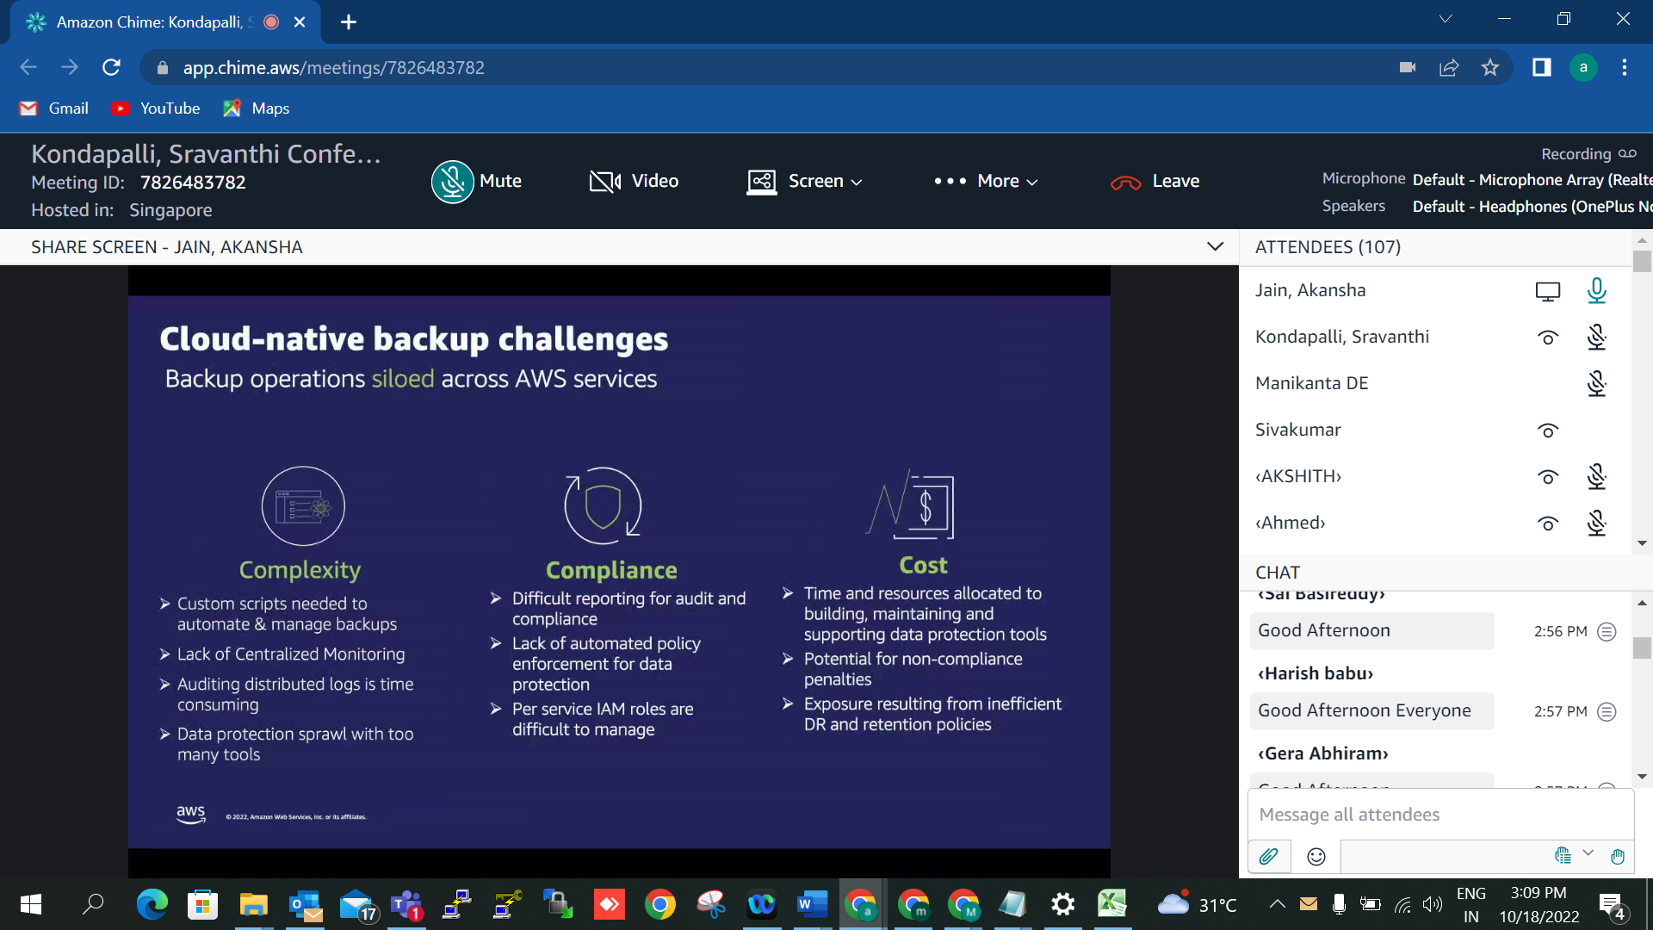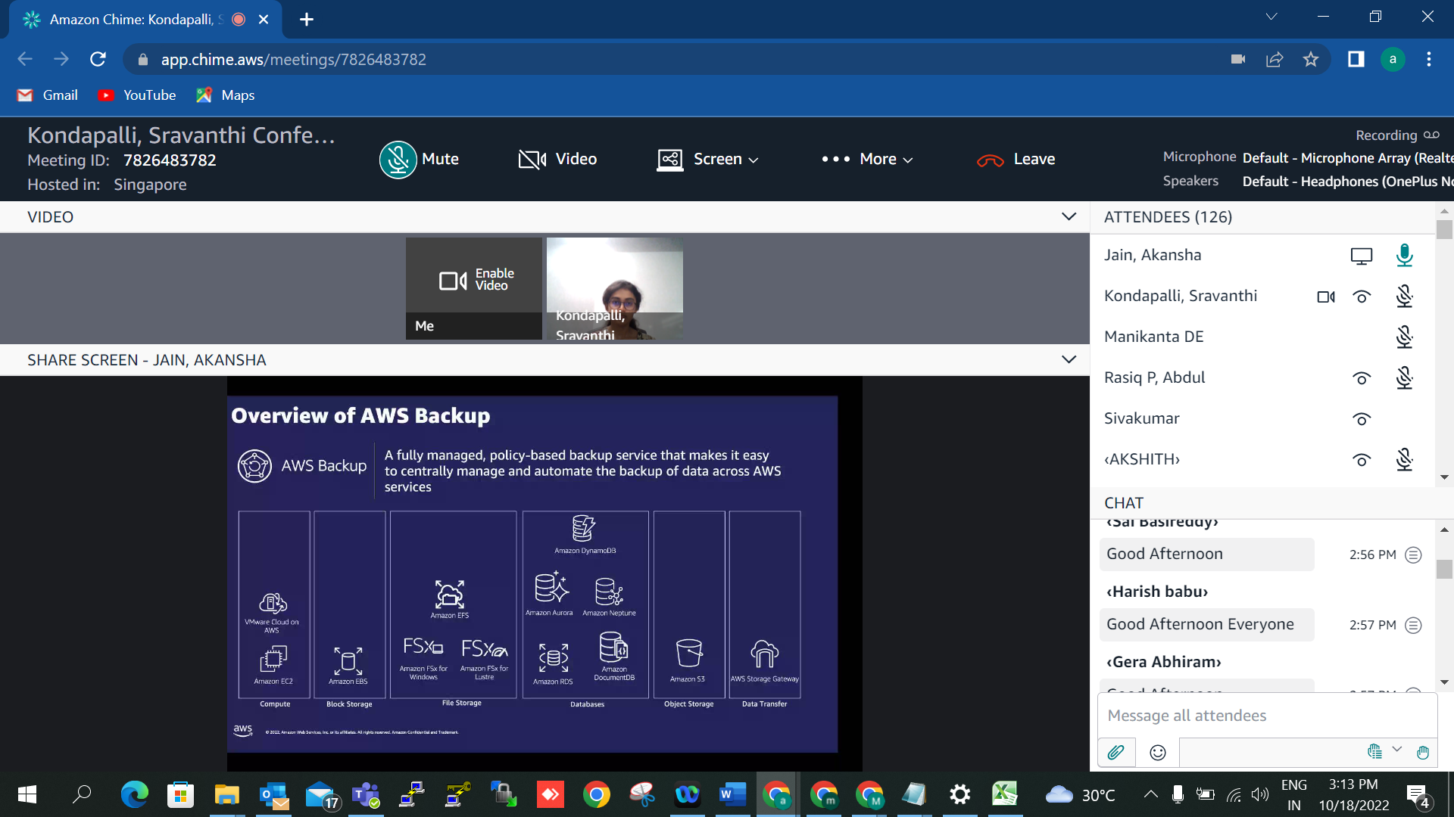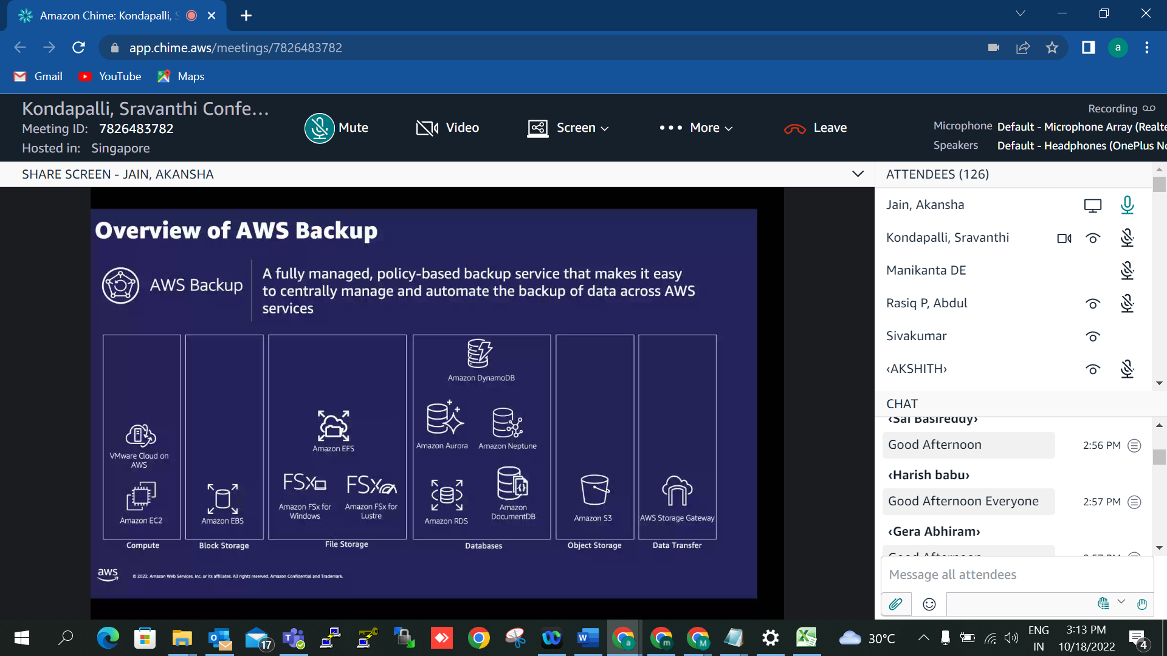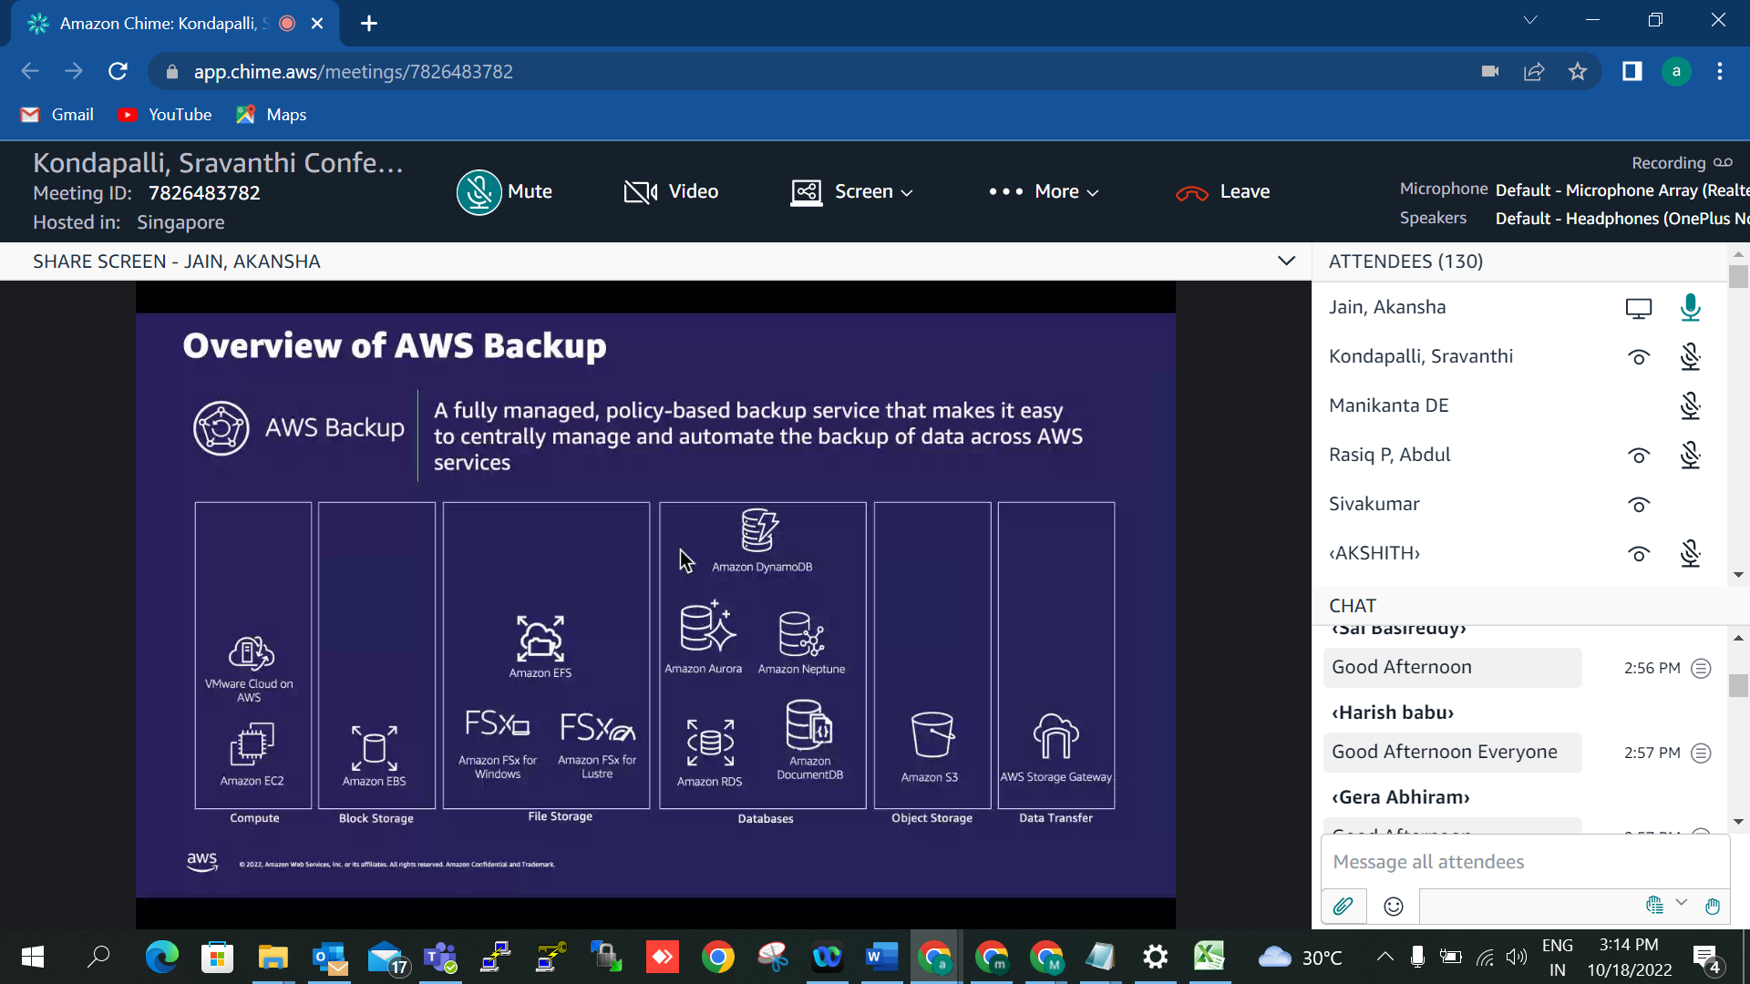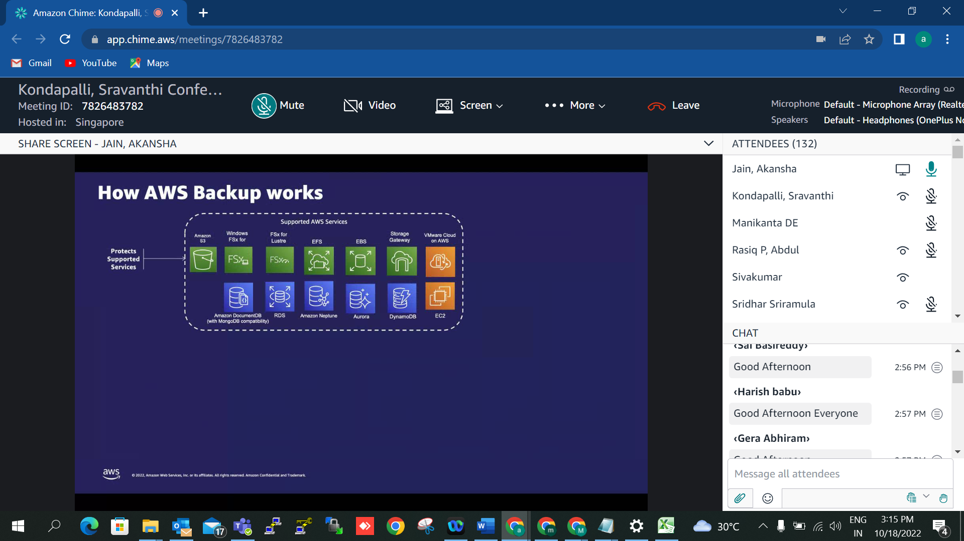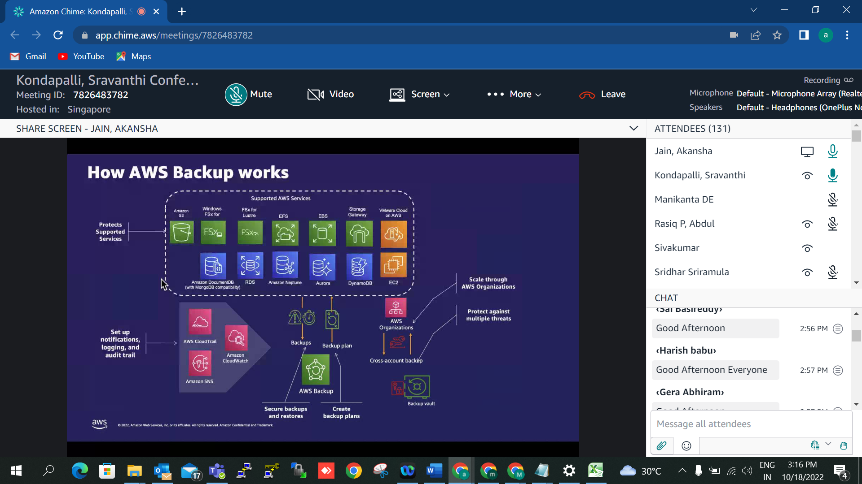kondaysr@amazon.com

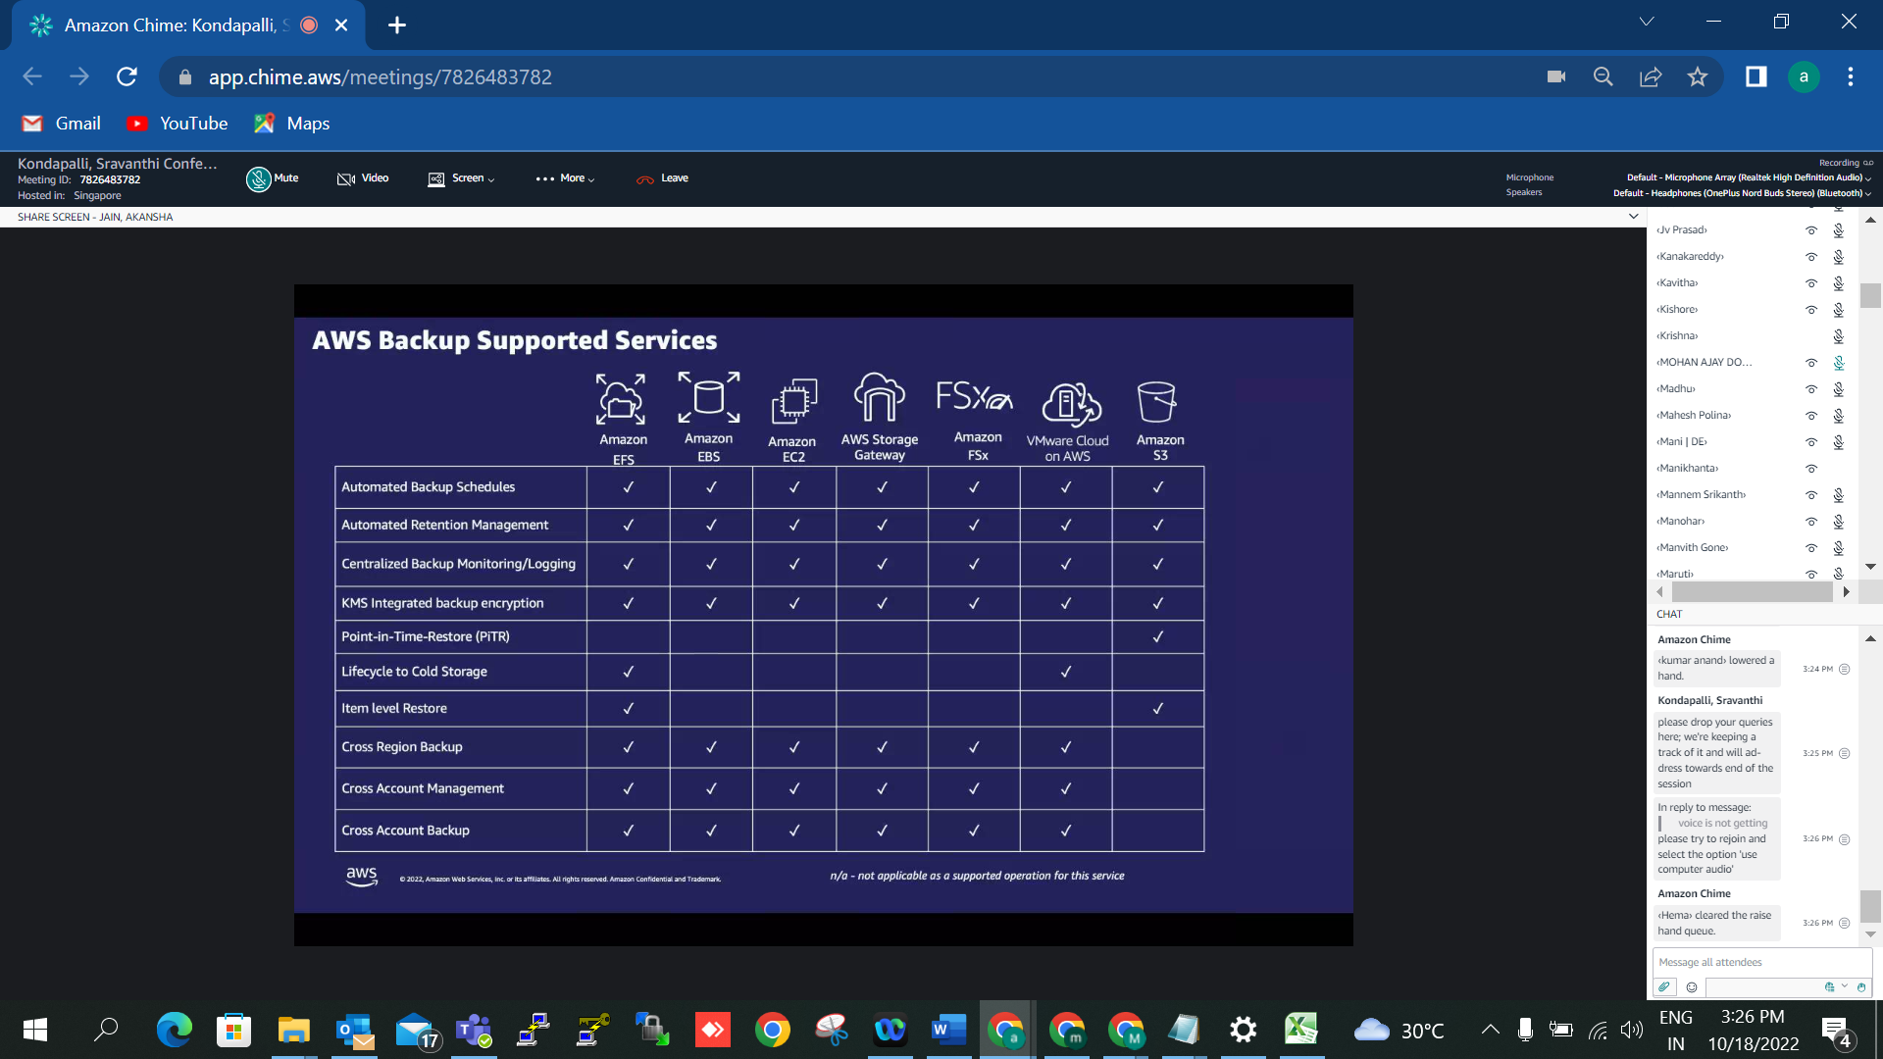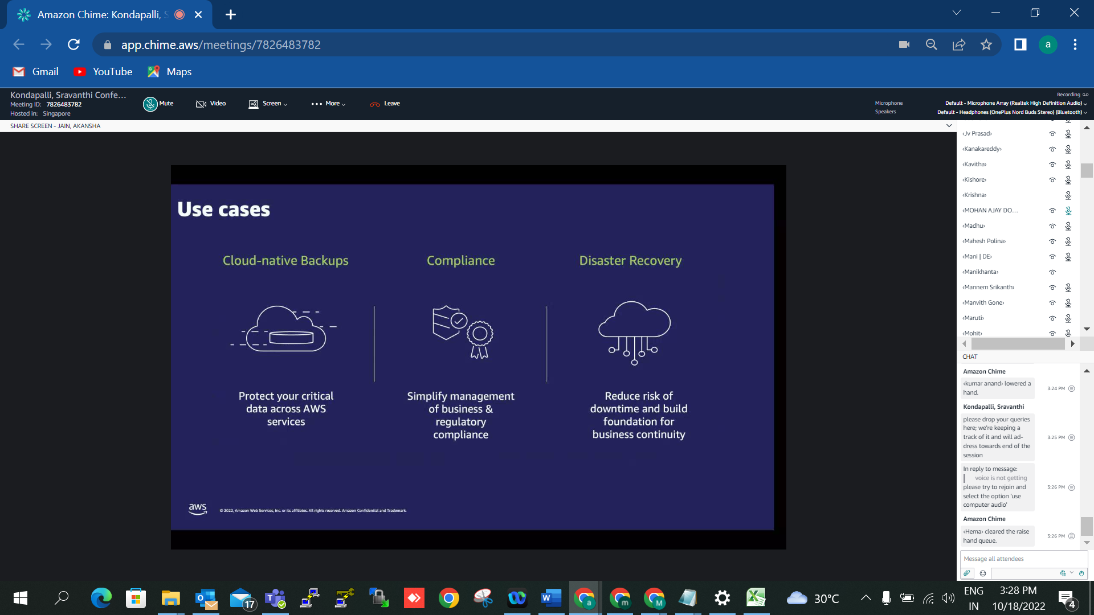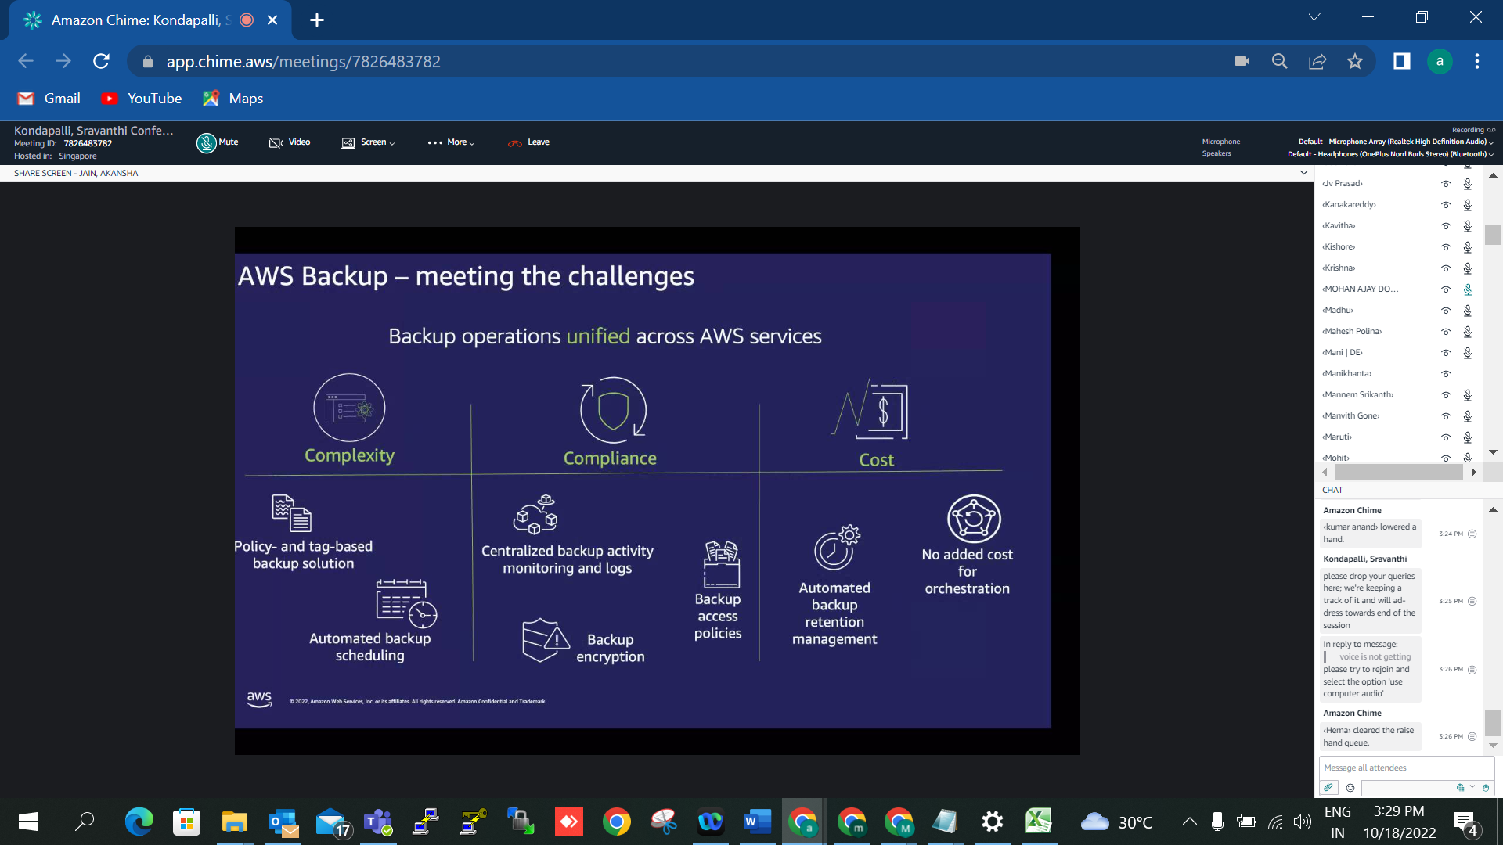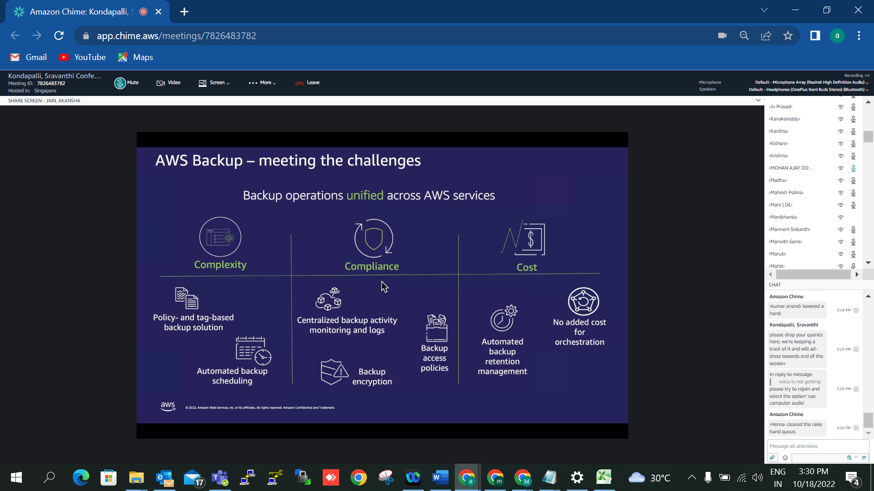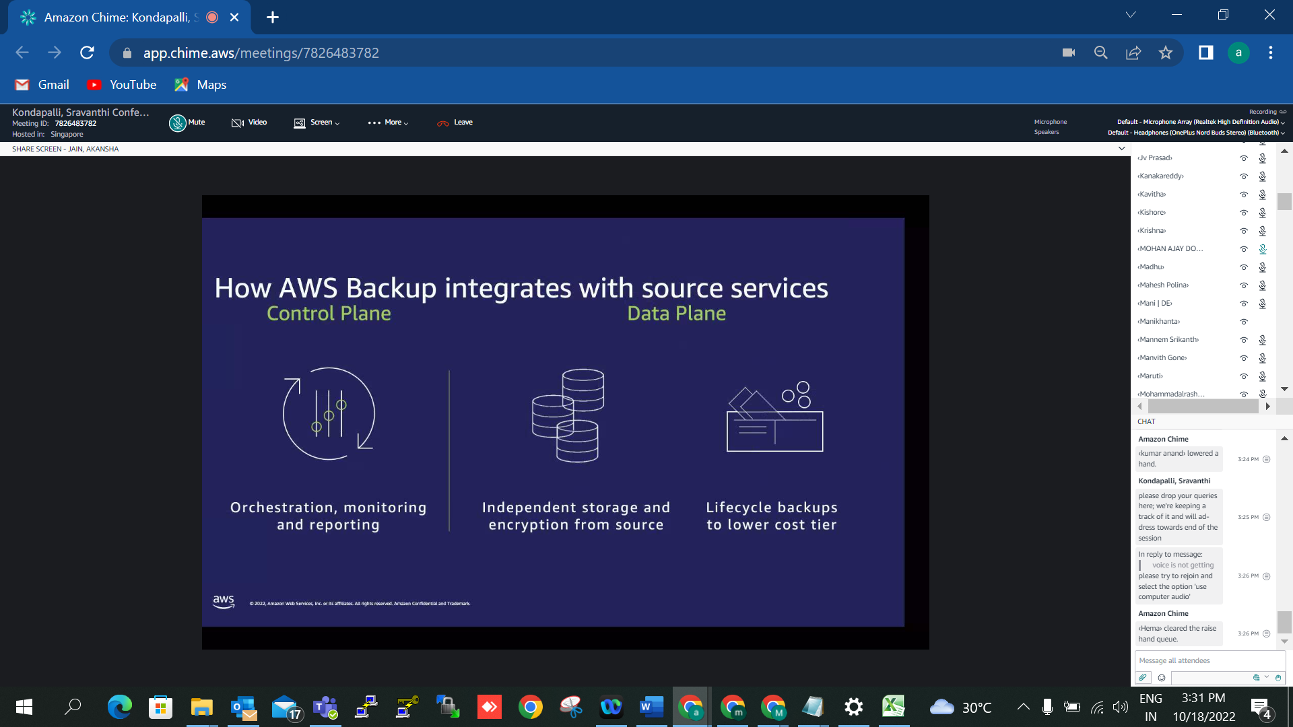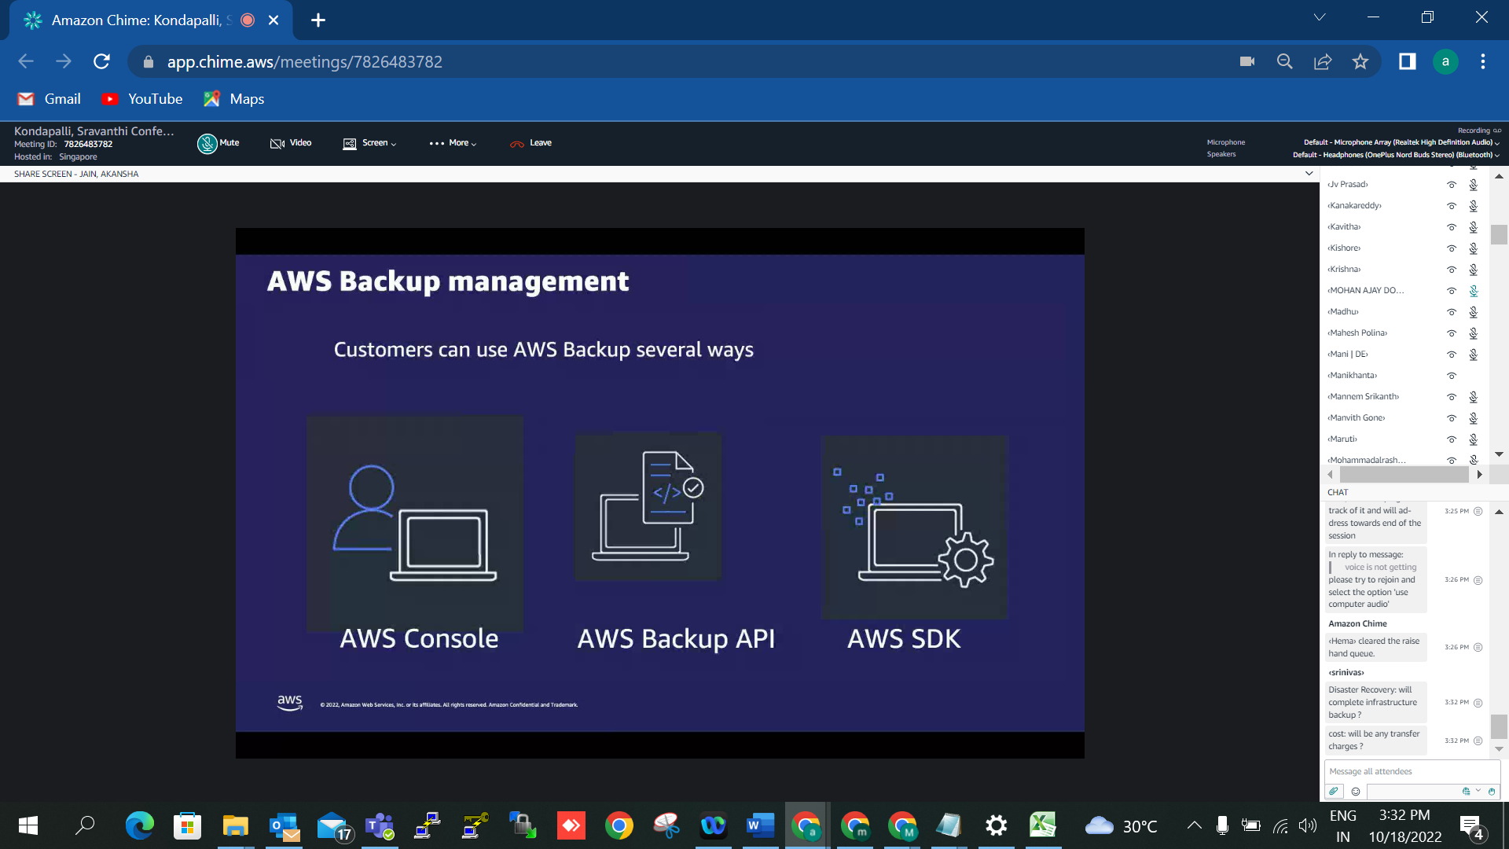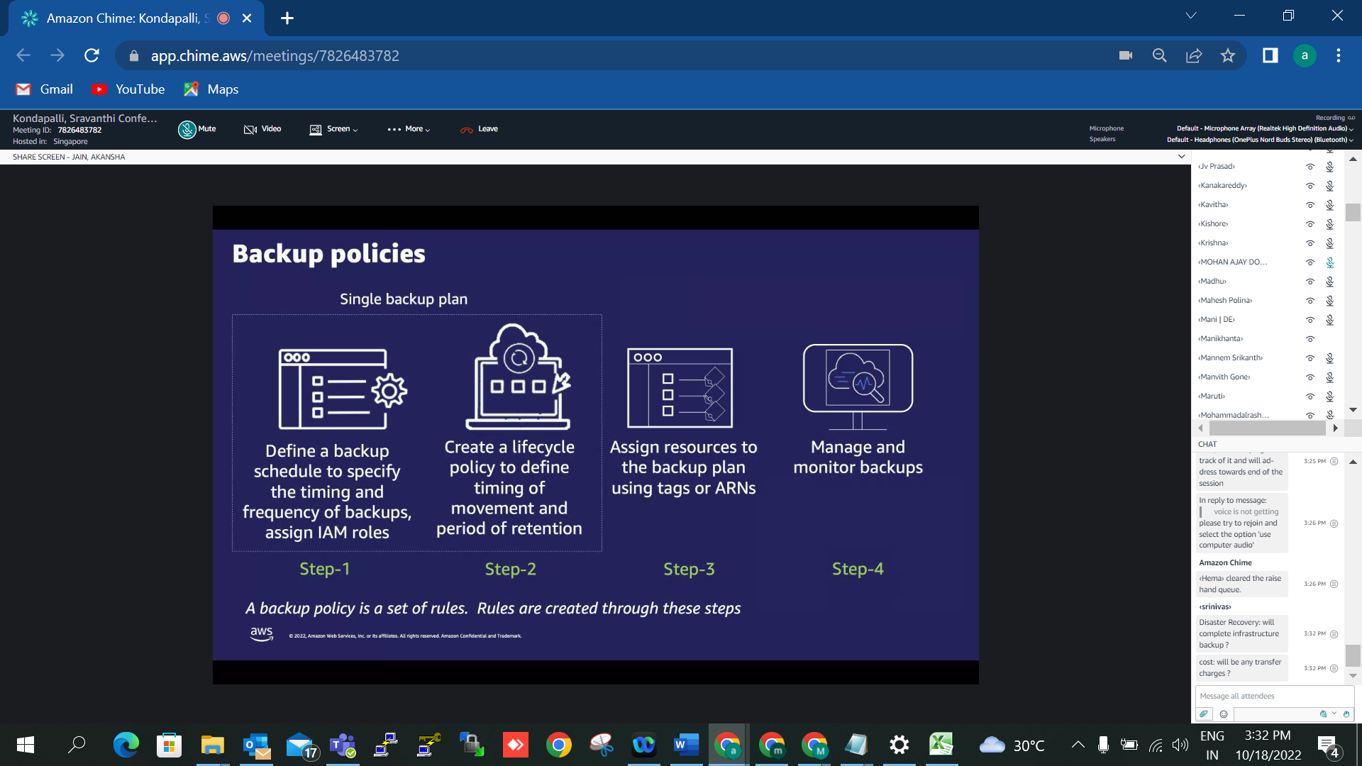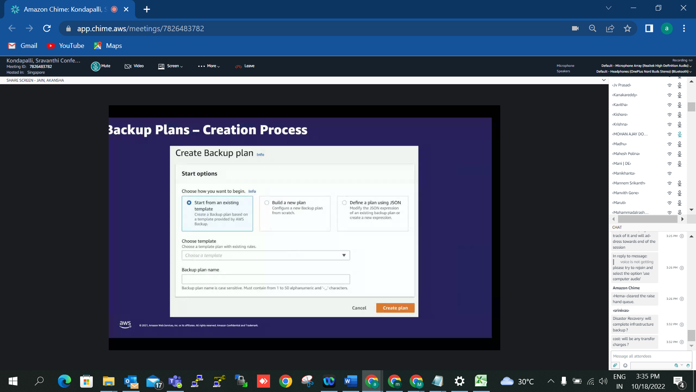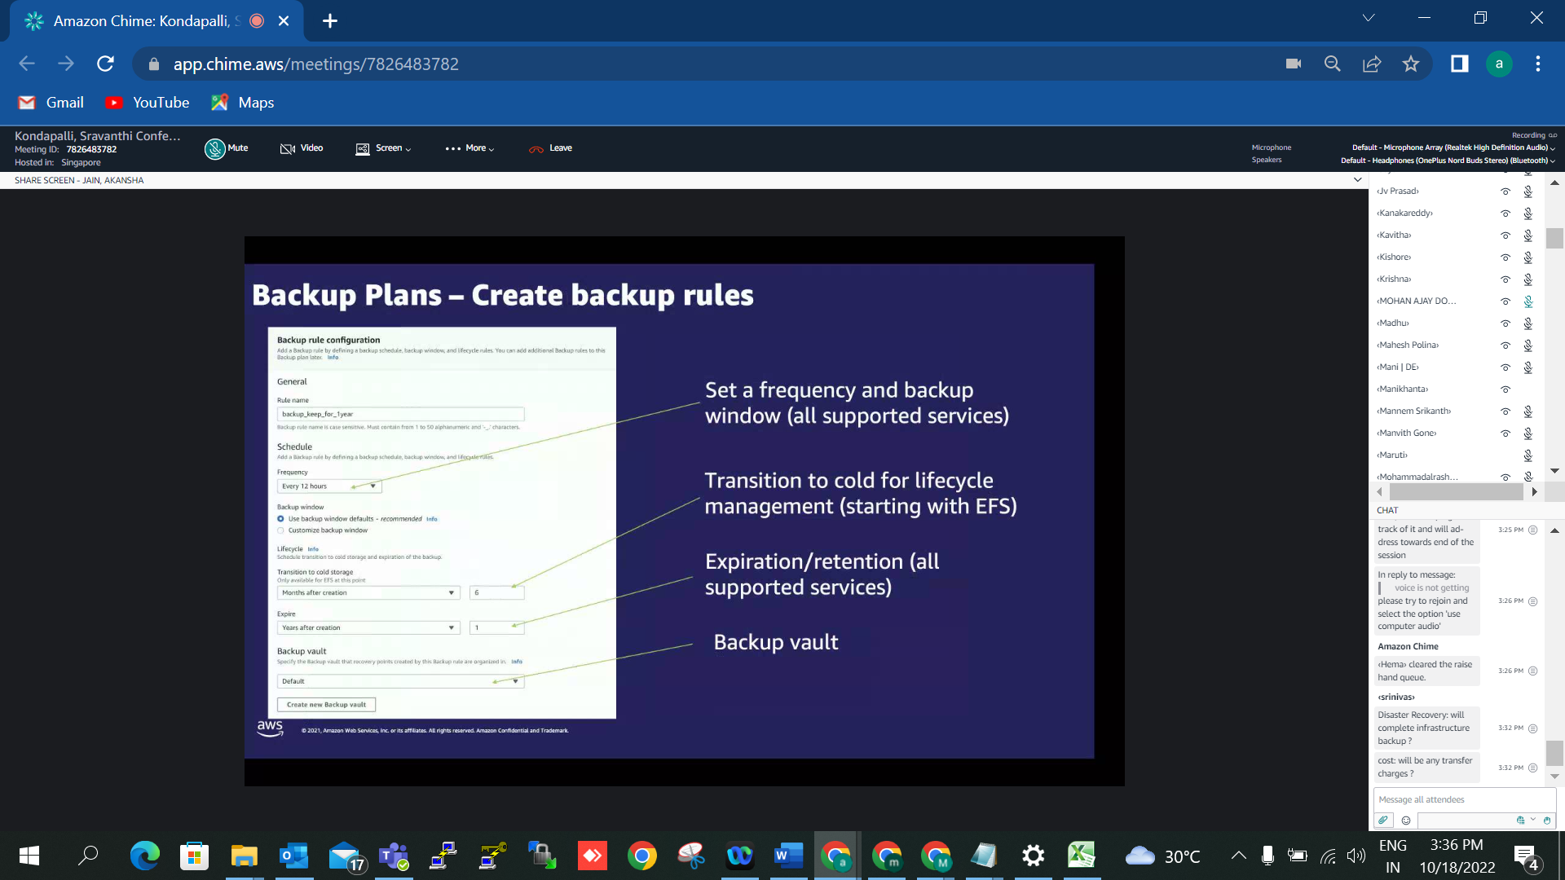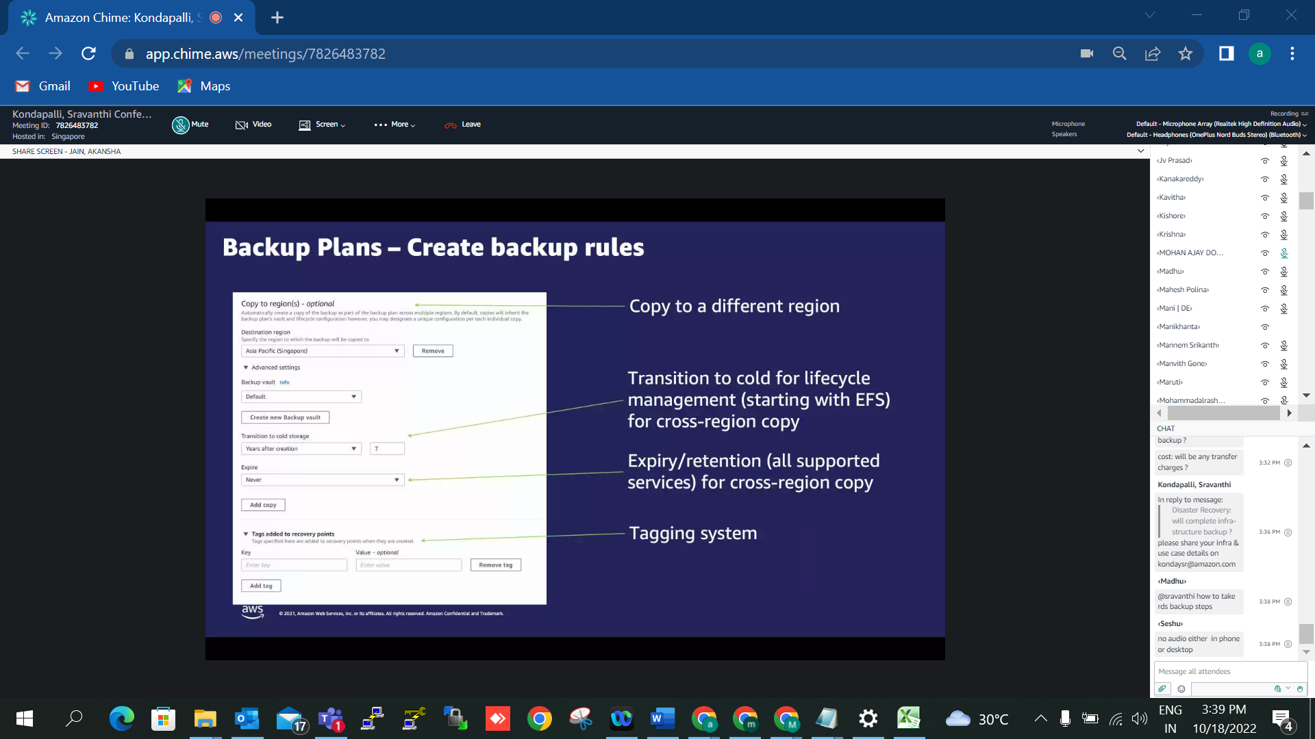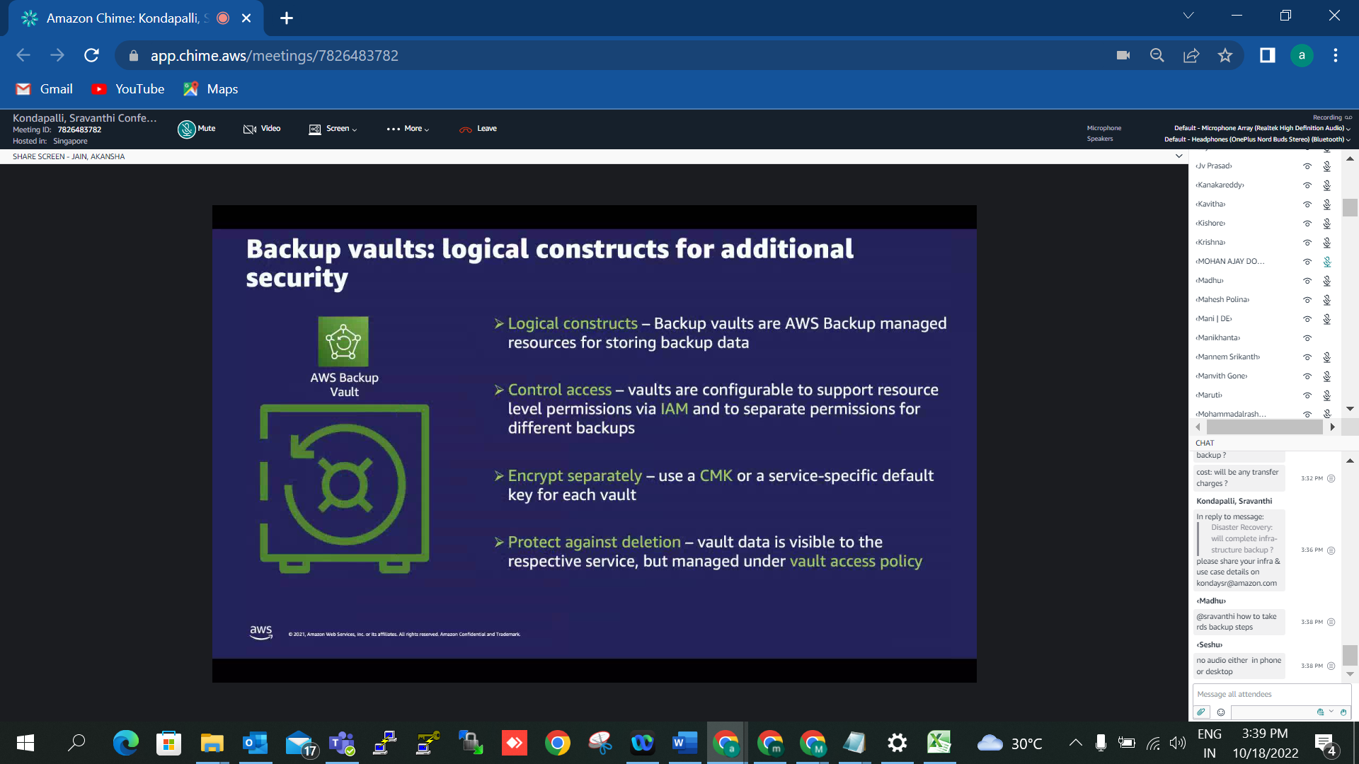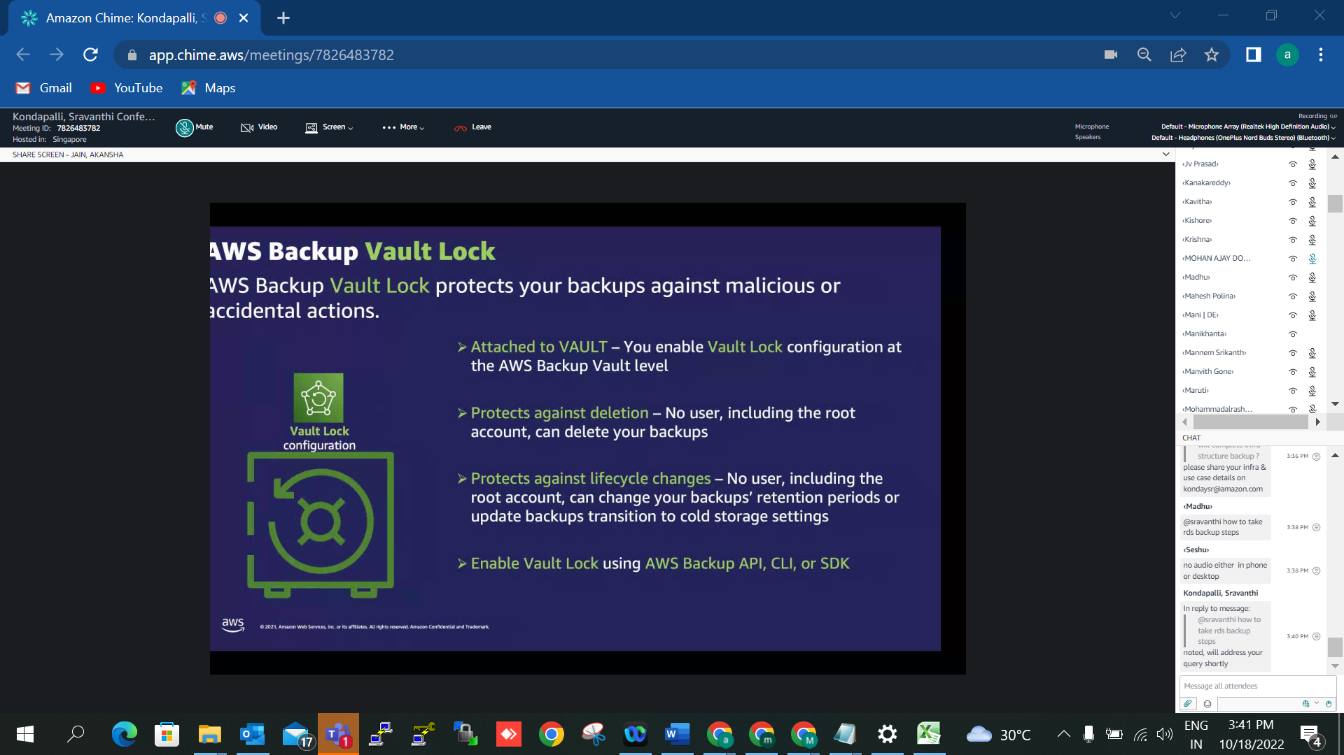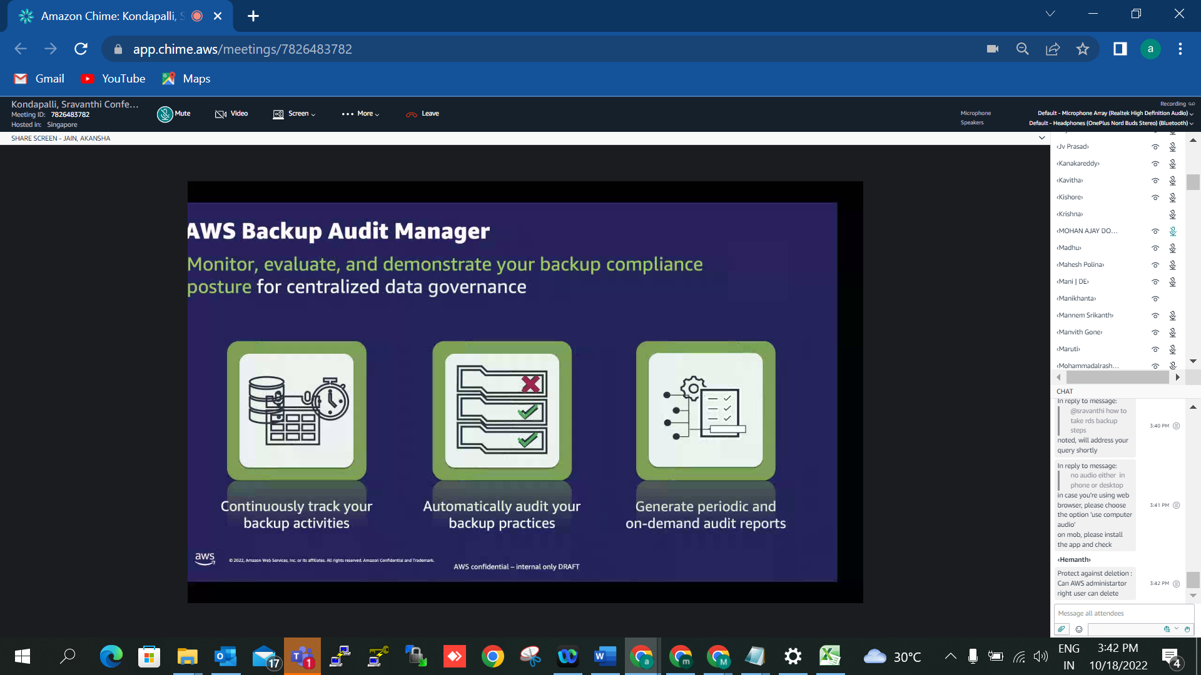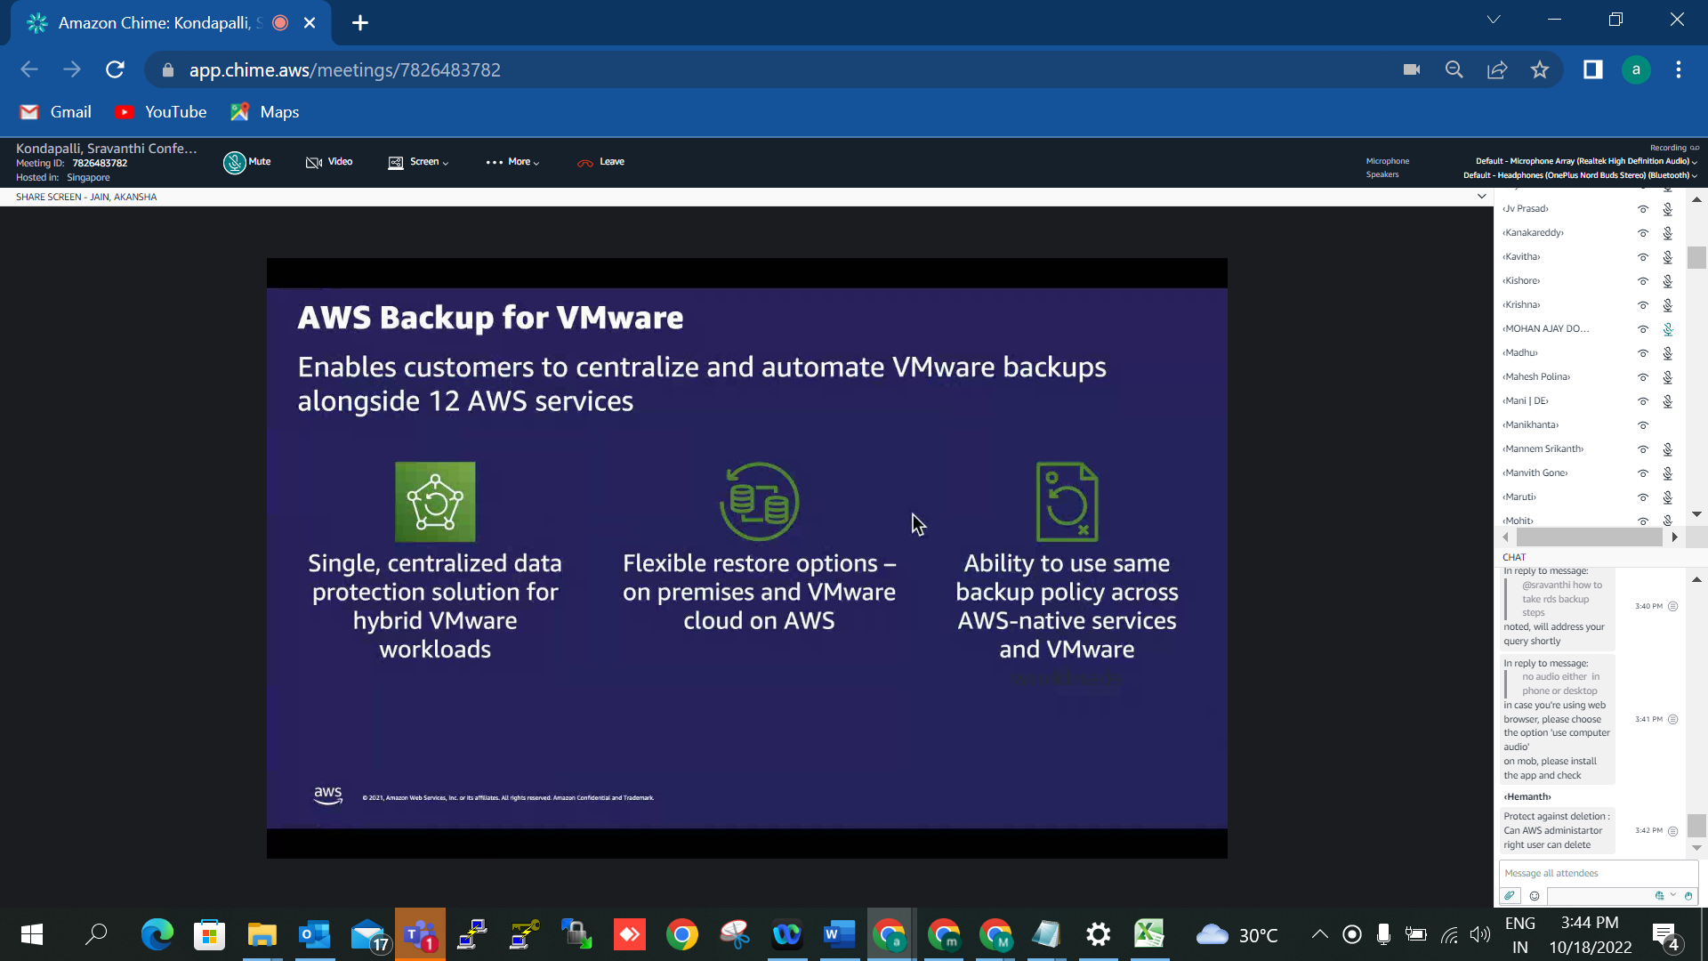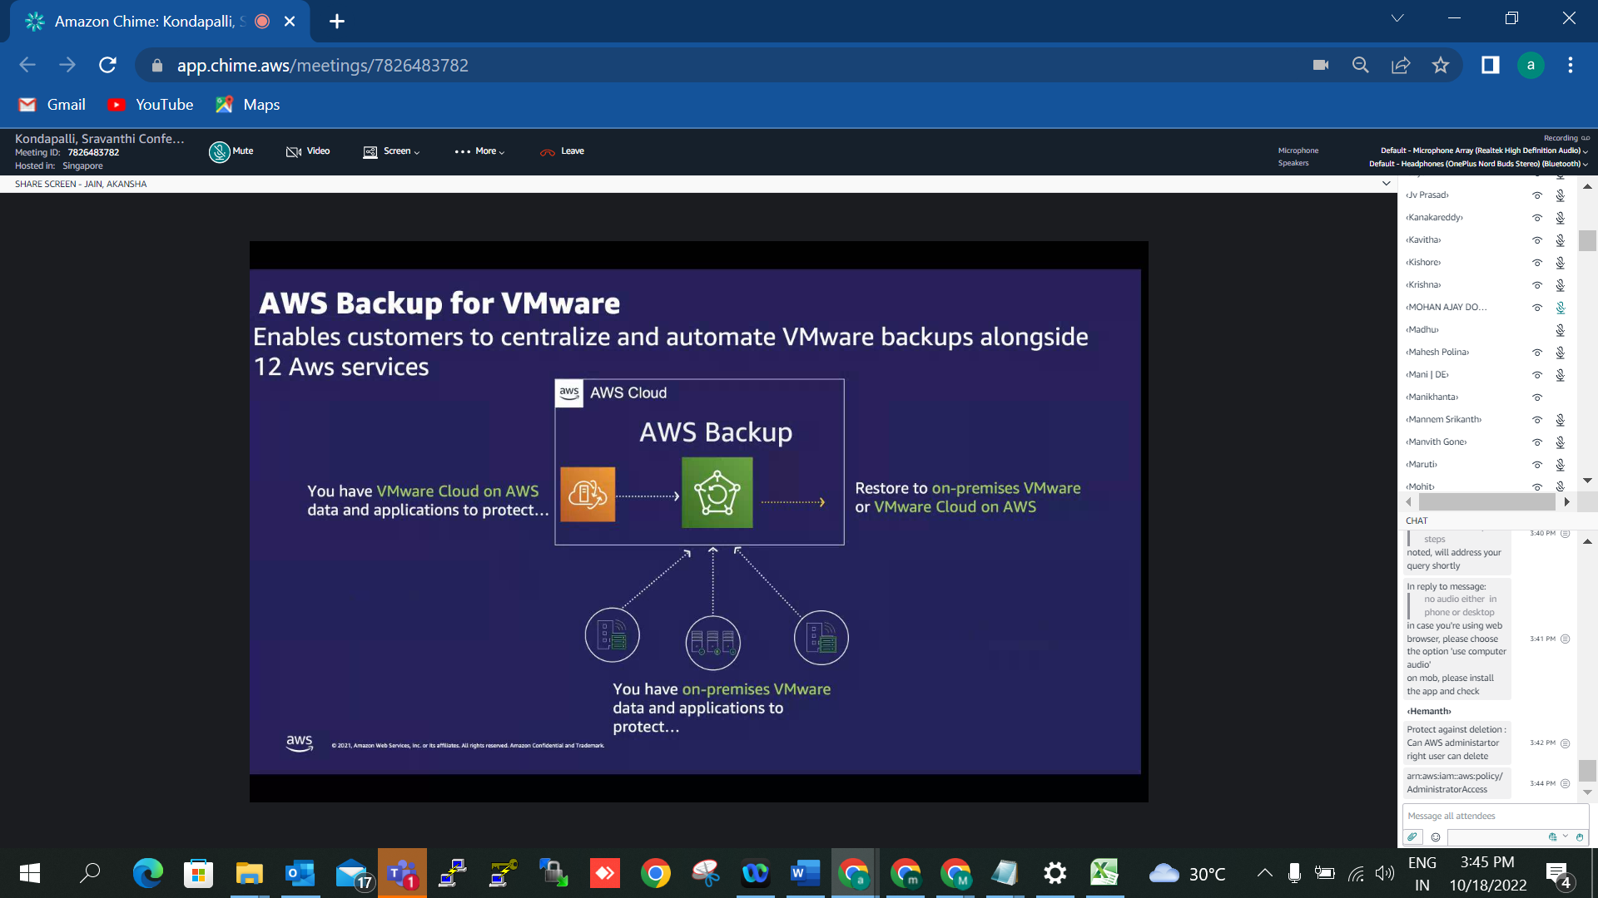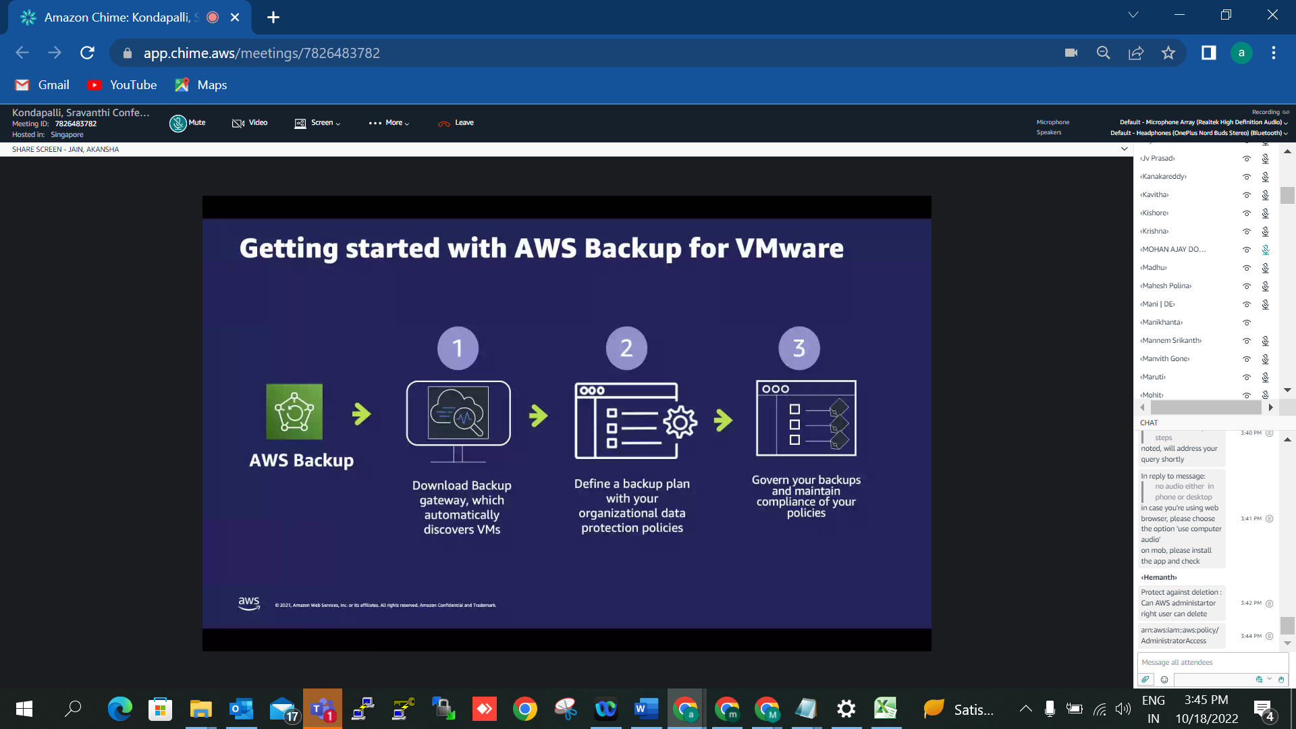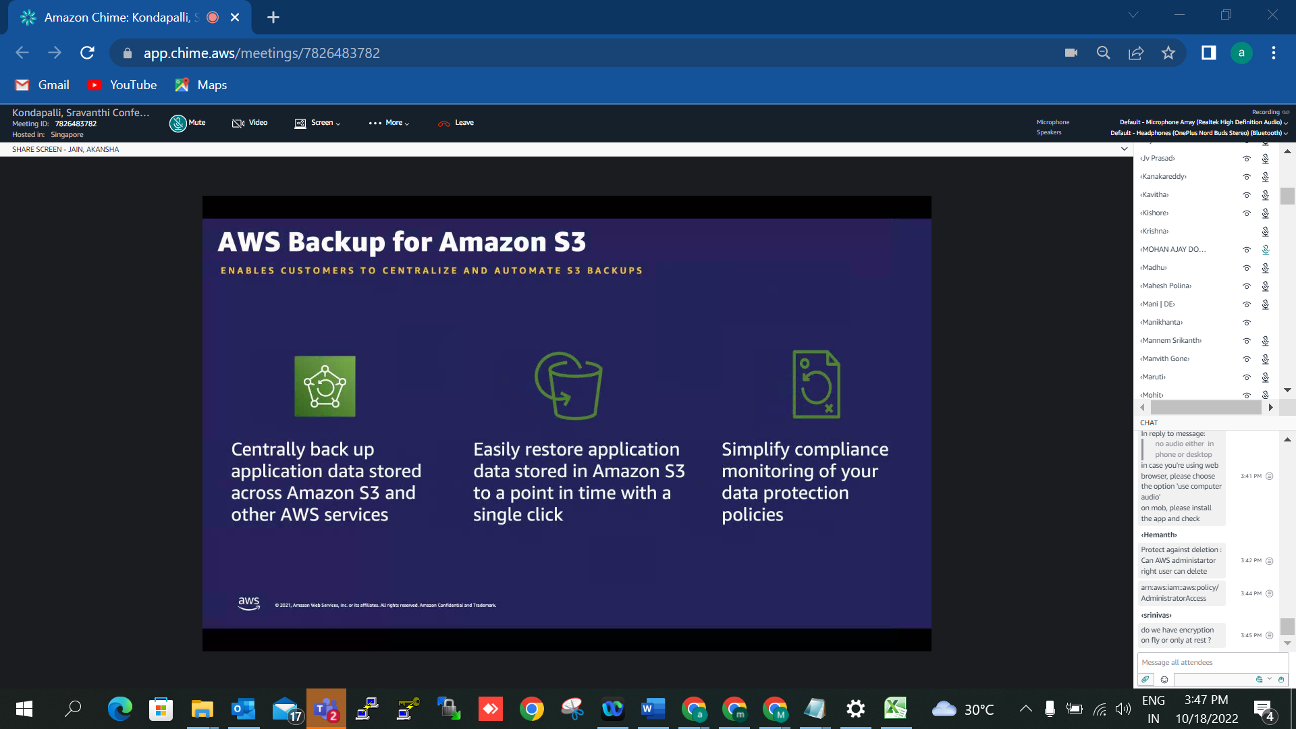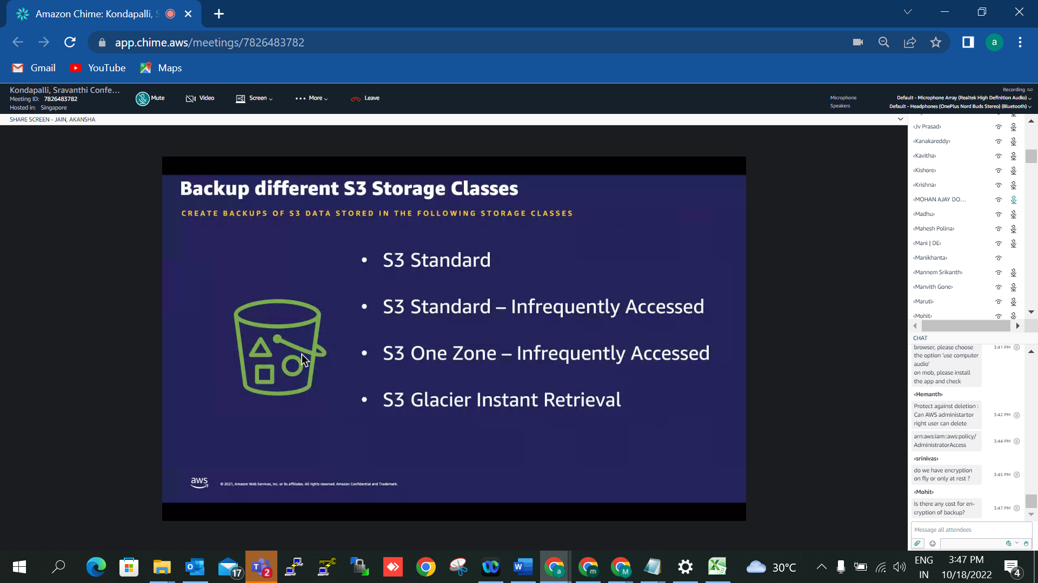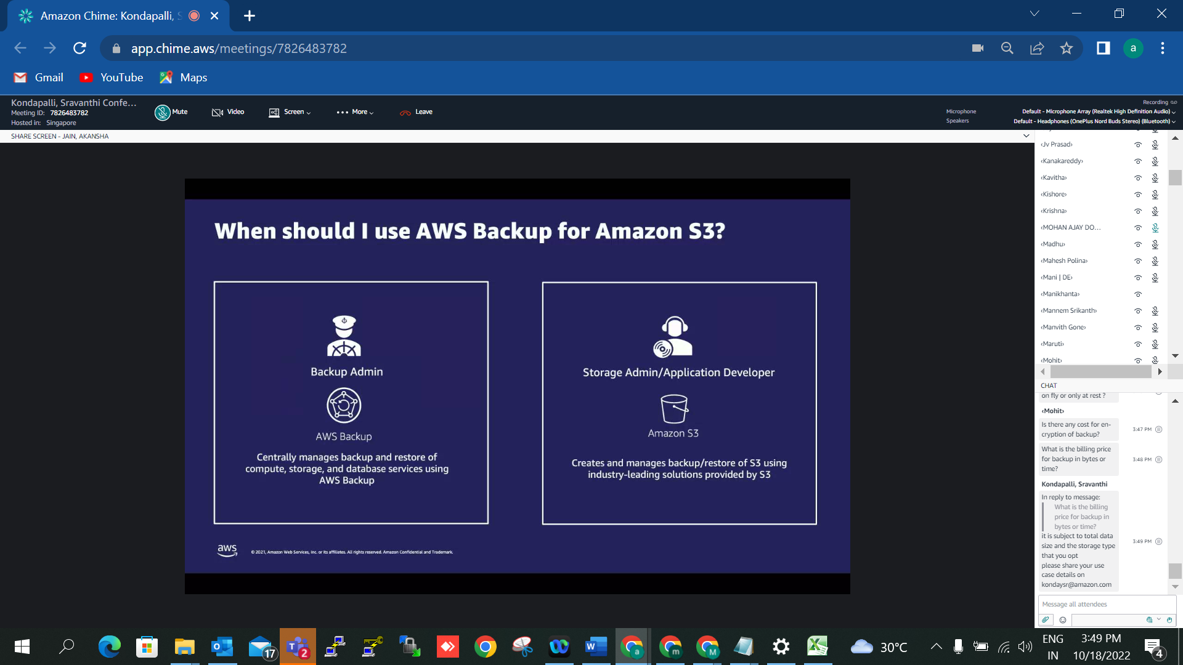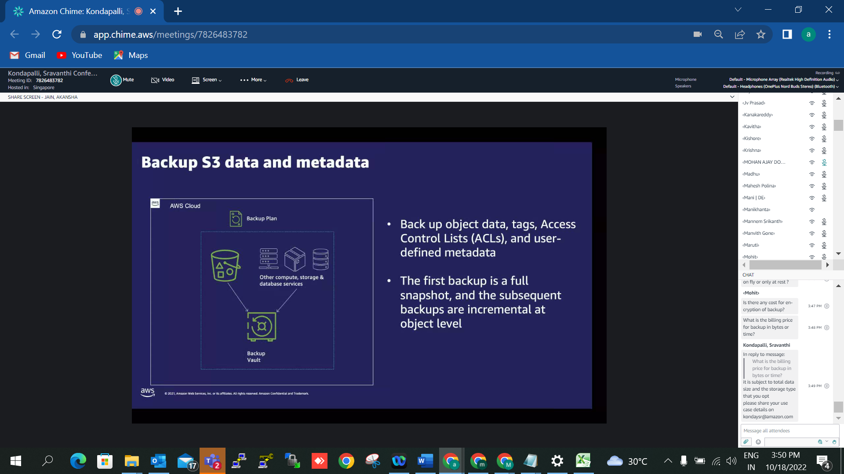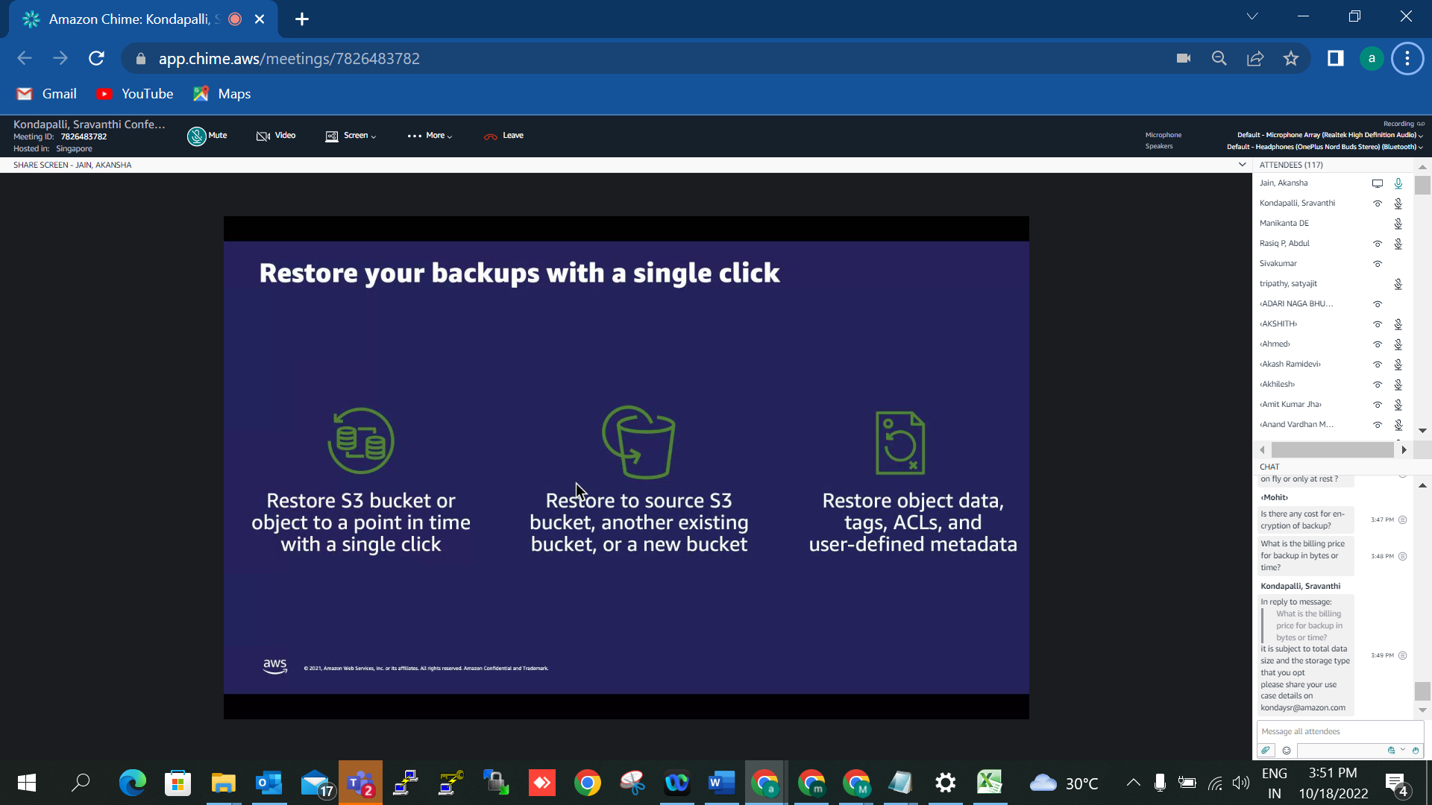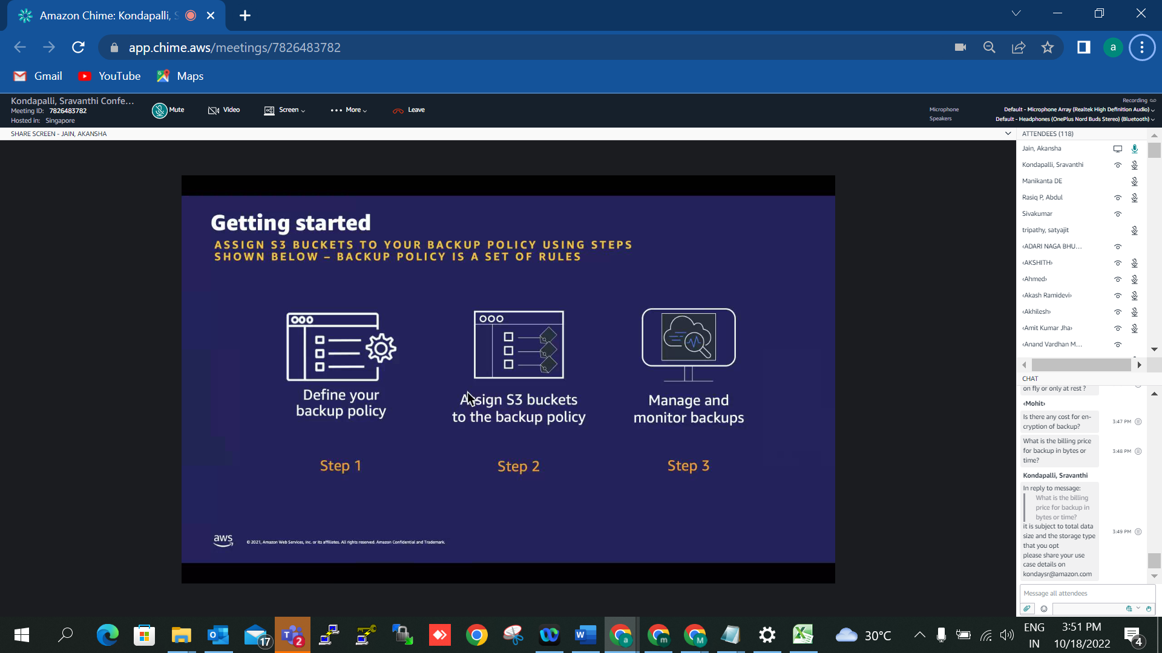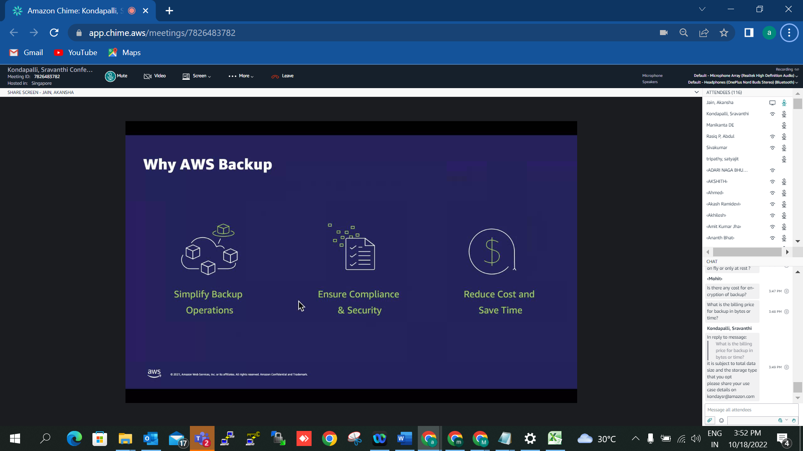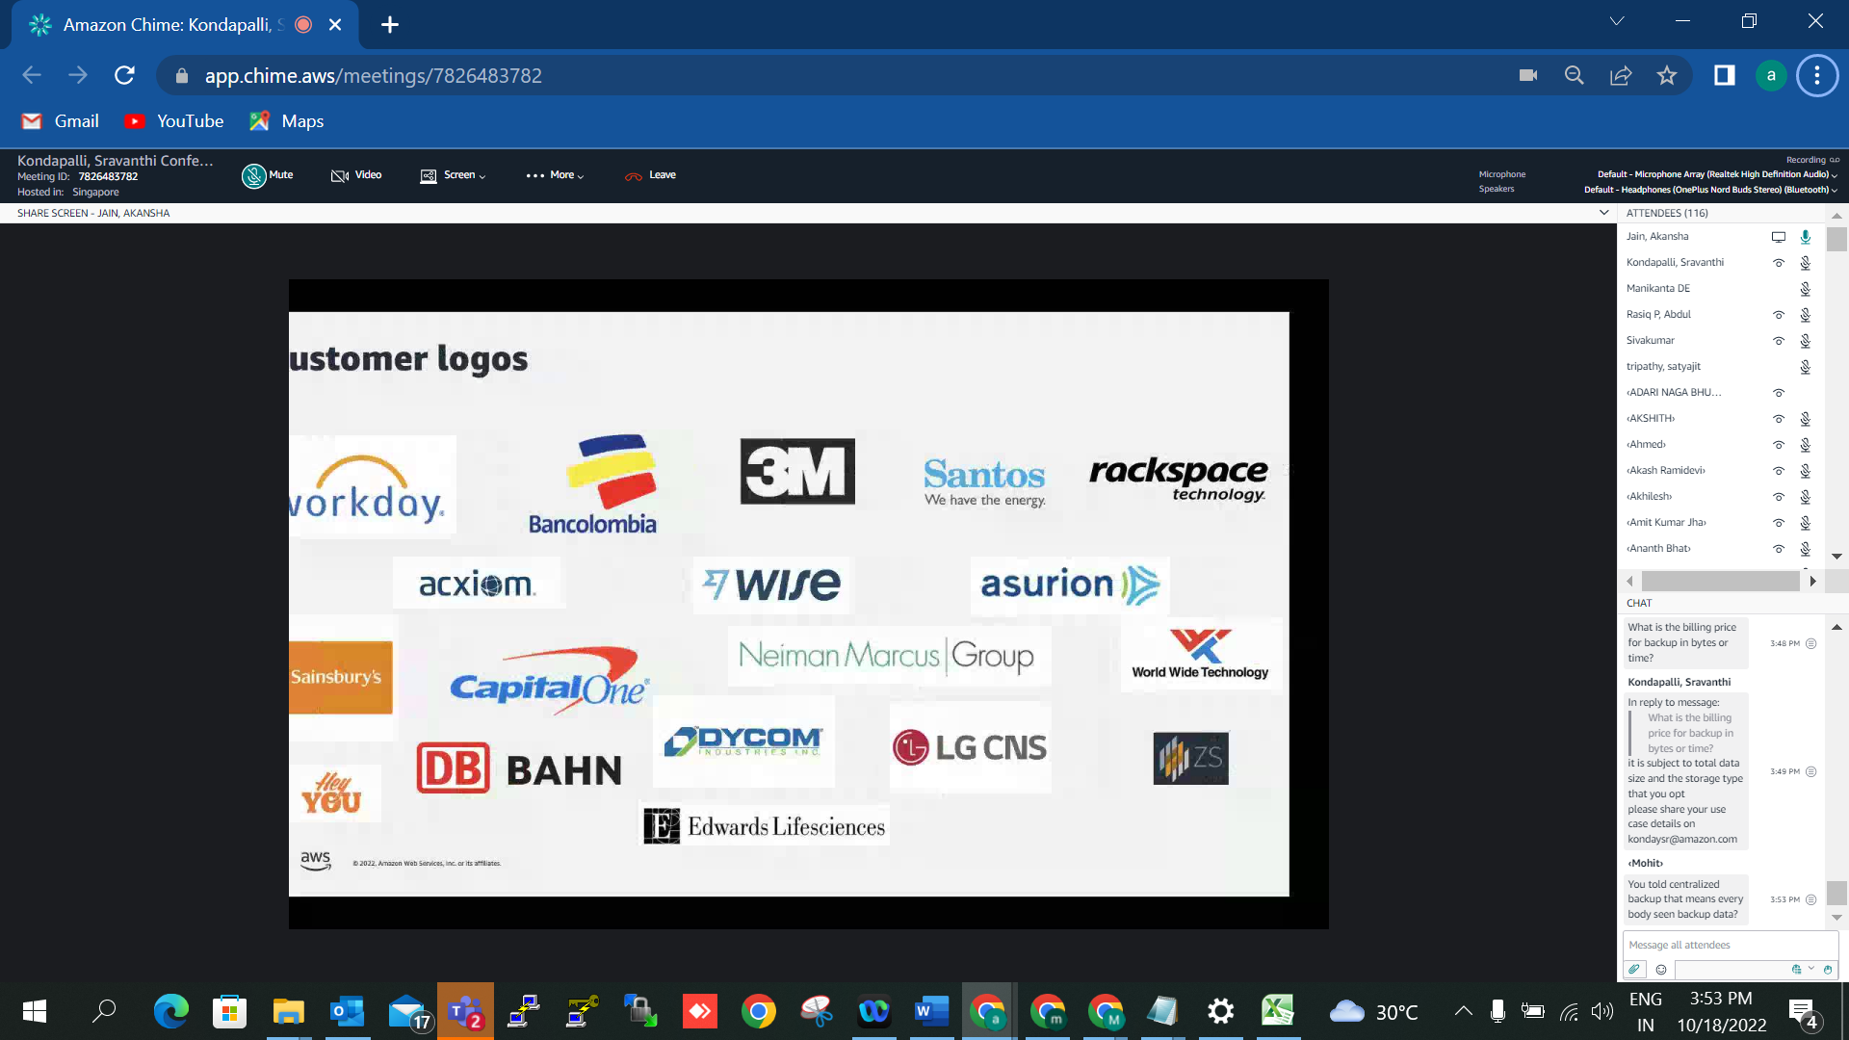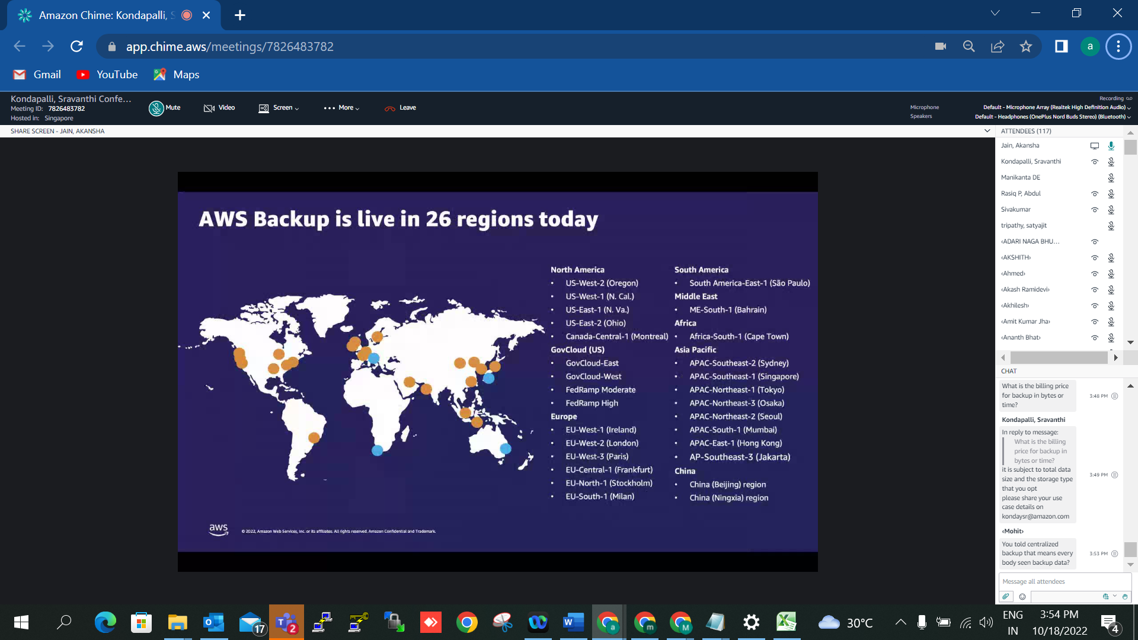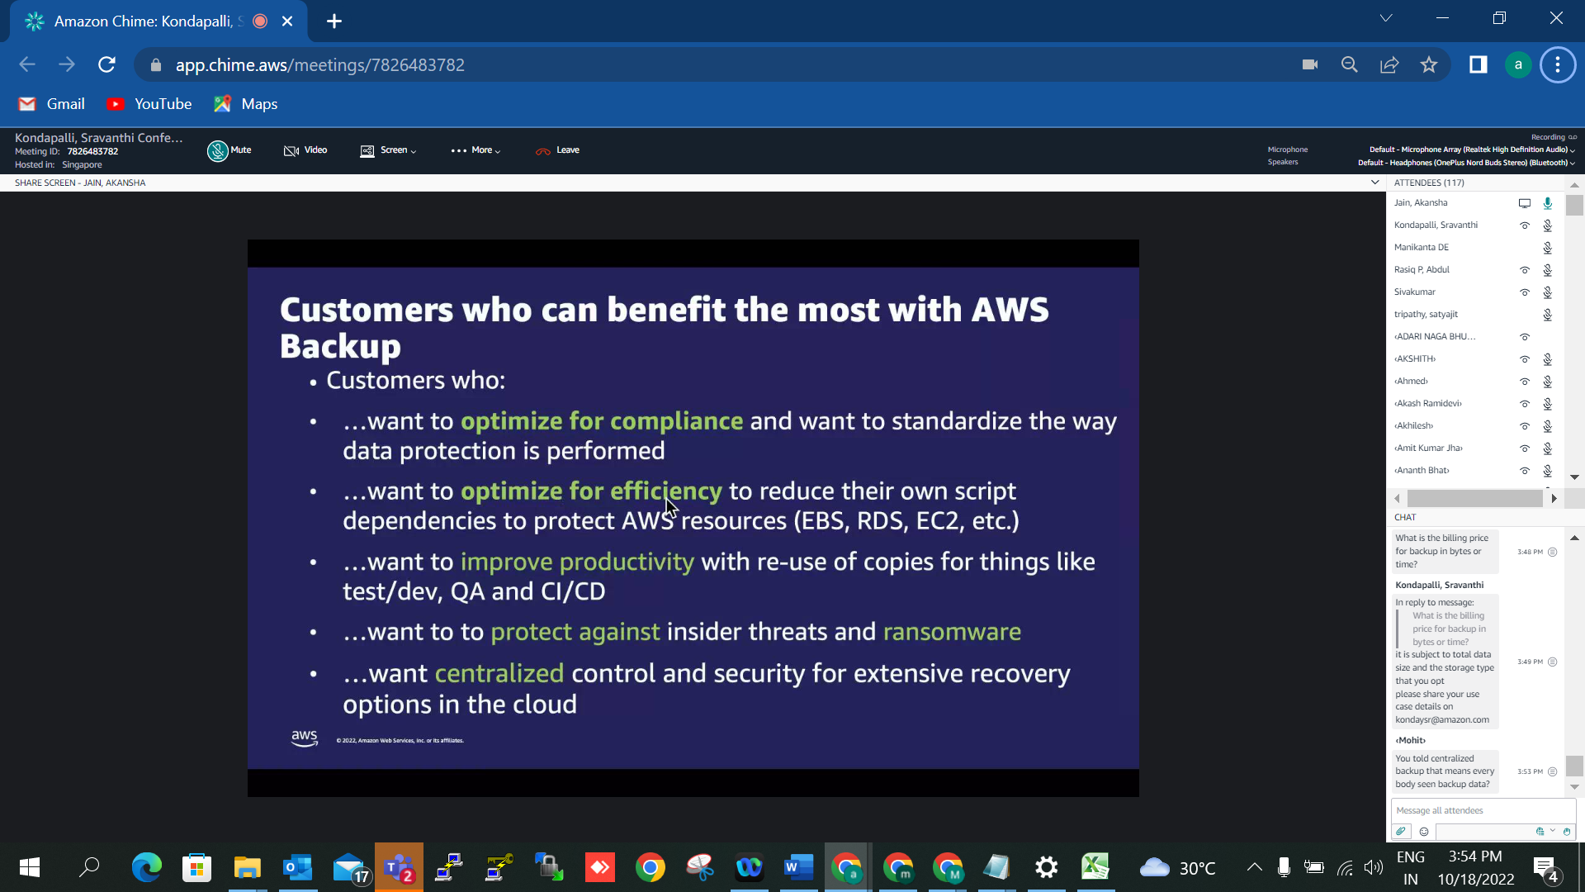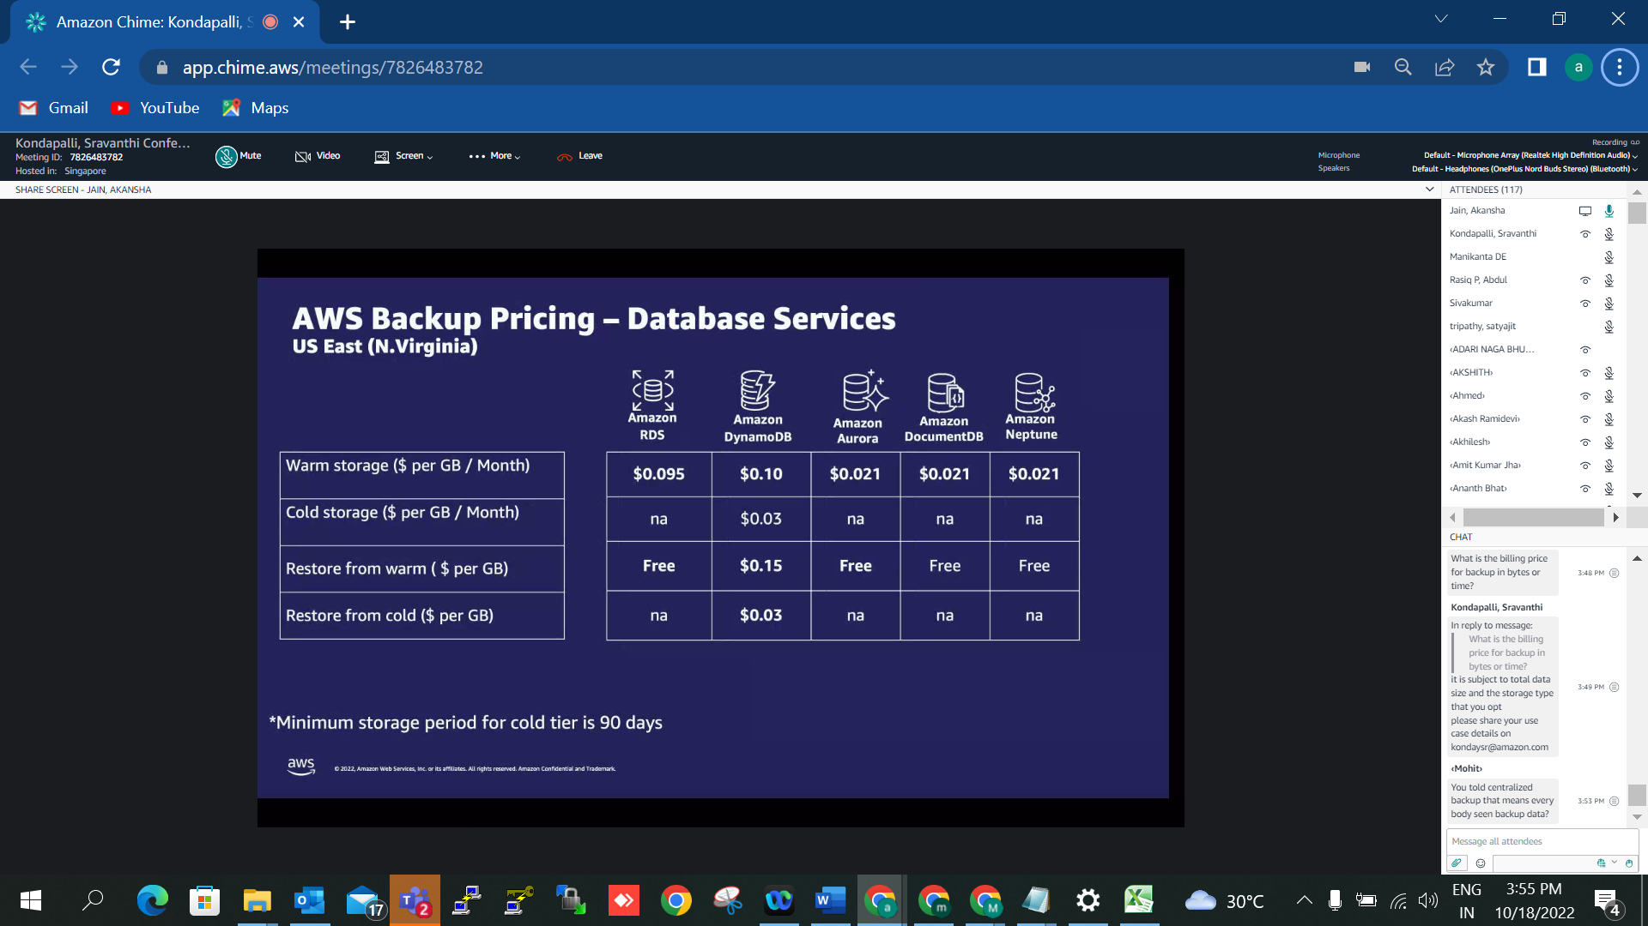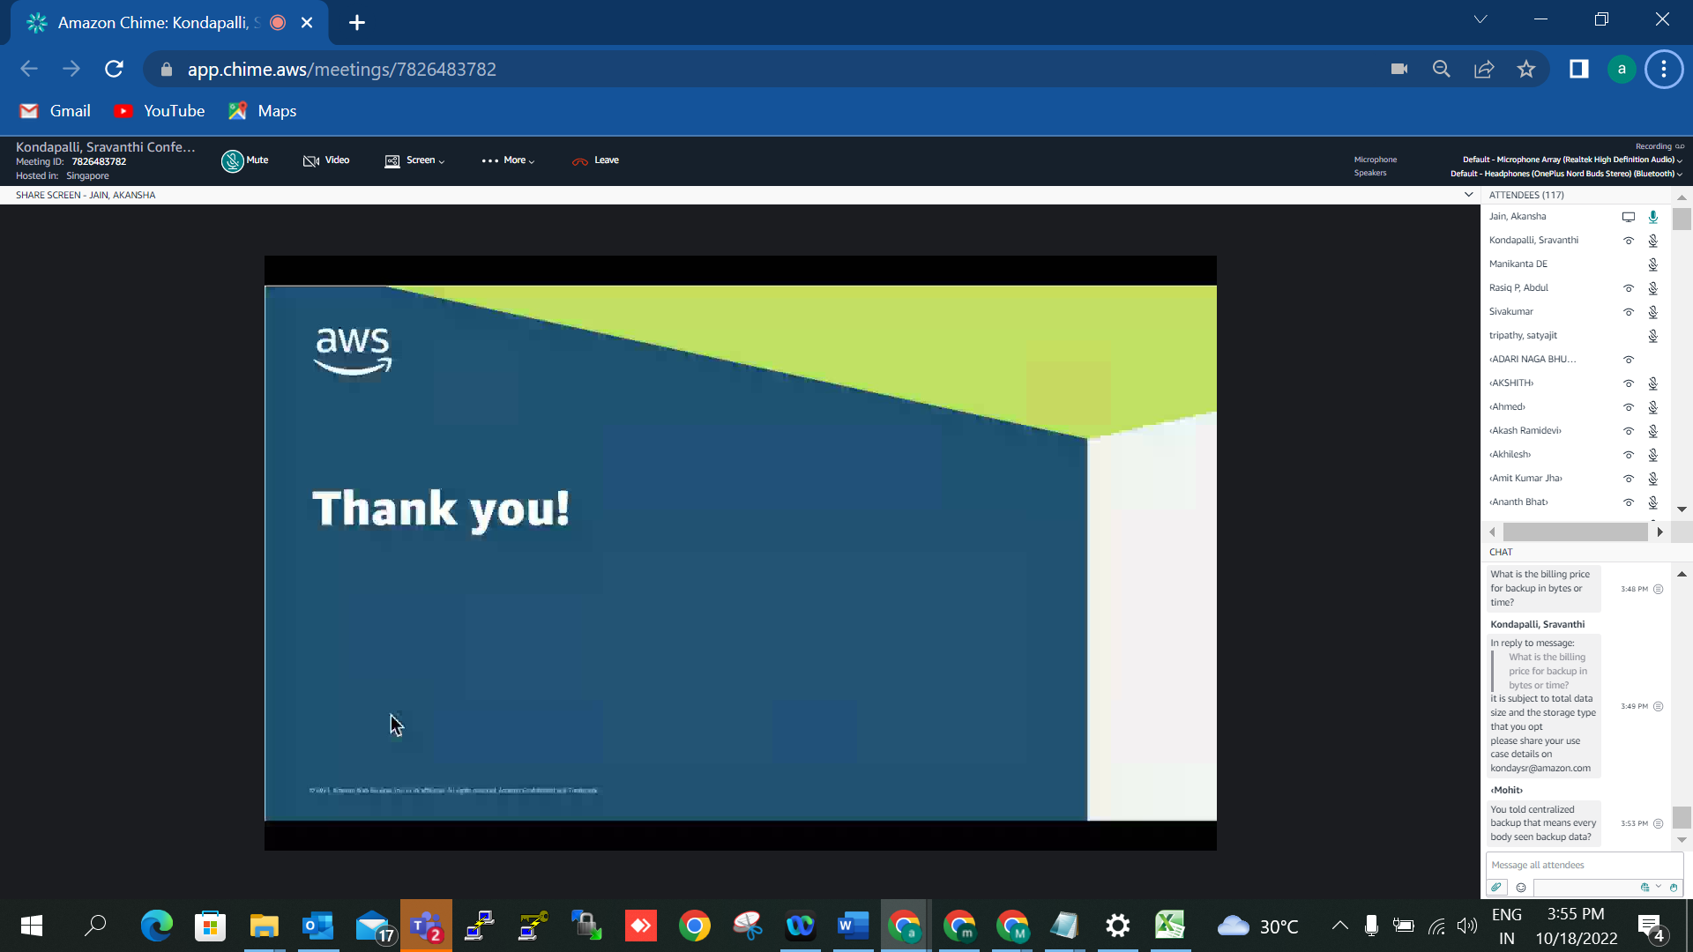

Meeting title: Kondapalli, Sravanthi Conference Bridge

Personalized ID: 7826483782

Meeting ID: 7826 48 3782

Hosting Region: Singapore

URL Link: https://chime.aws/7826483782

US dial-in: +1 206-462-5569

US toll-free dial-in: +1 855-552-4463

International dial-in numbers: https://chime.aws/dialinnumbers/